**CompTIA Linux+: Scripting, Containers, and Automation**

# Chapter 1: Course Overview

## Chapter 1.1: Course Overview

# Chapter 2: Implementing Version Control Using Git

## Chapter 2.1: Introduction to Linux Automation

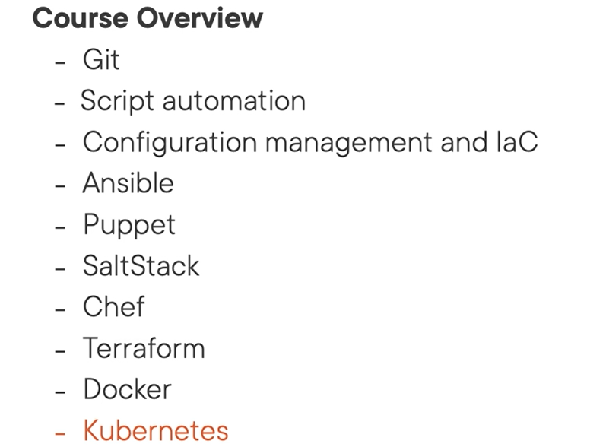

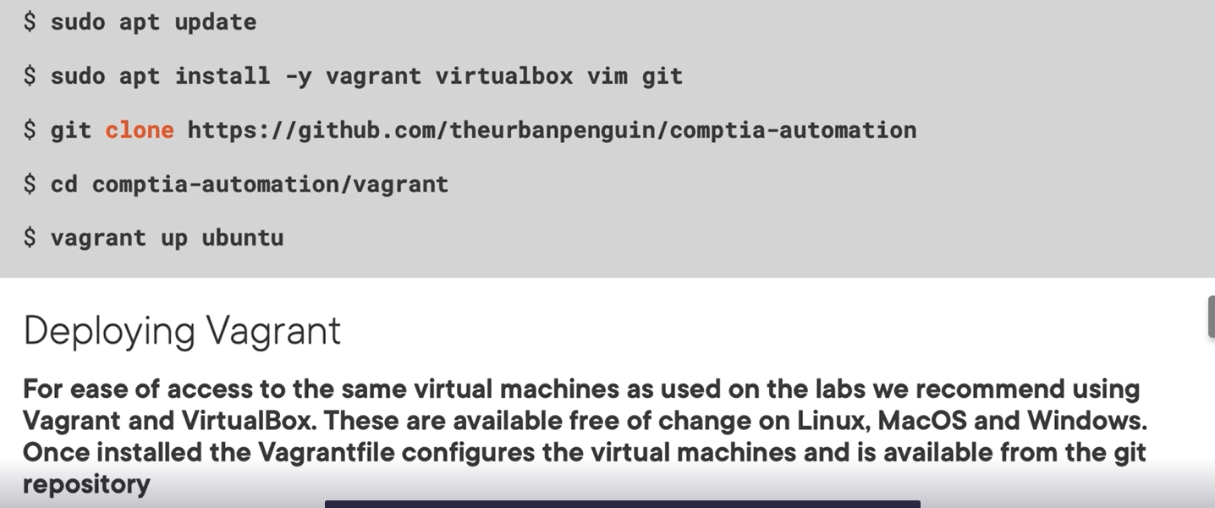

## Chapter 2.2: Installing Vagrant and VirtualBox

# apt-cache update -y

# apt install -y vagrant virtualbox vim git

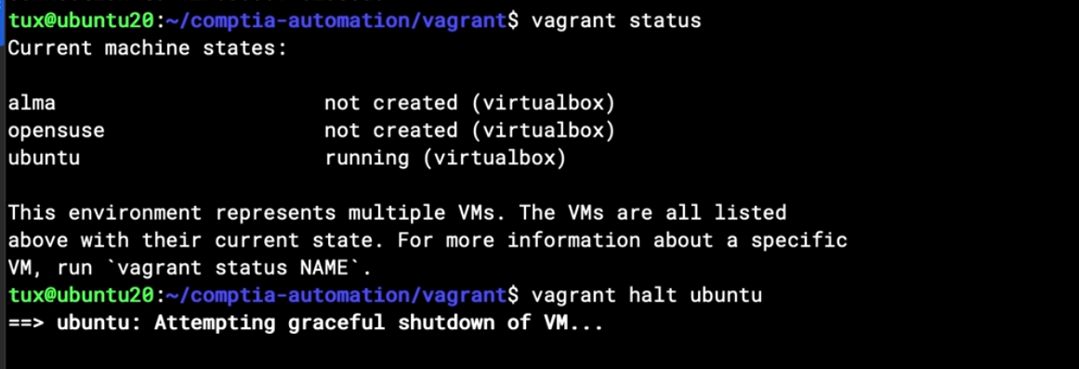

## Chapter 2.3: Using Git to Switch Branches

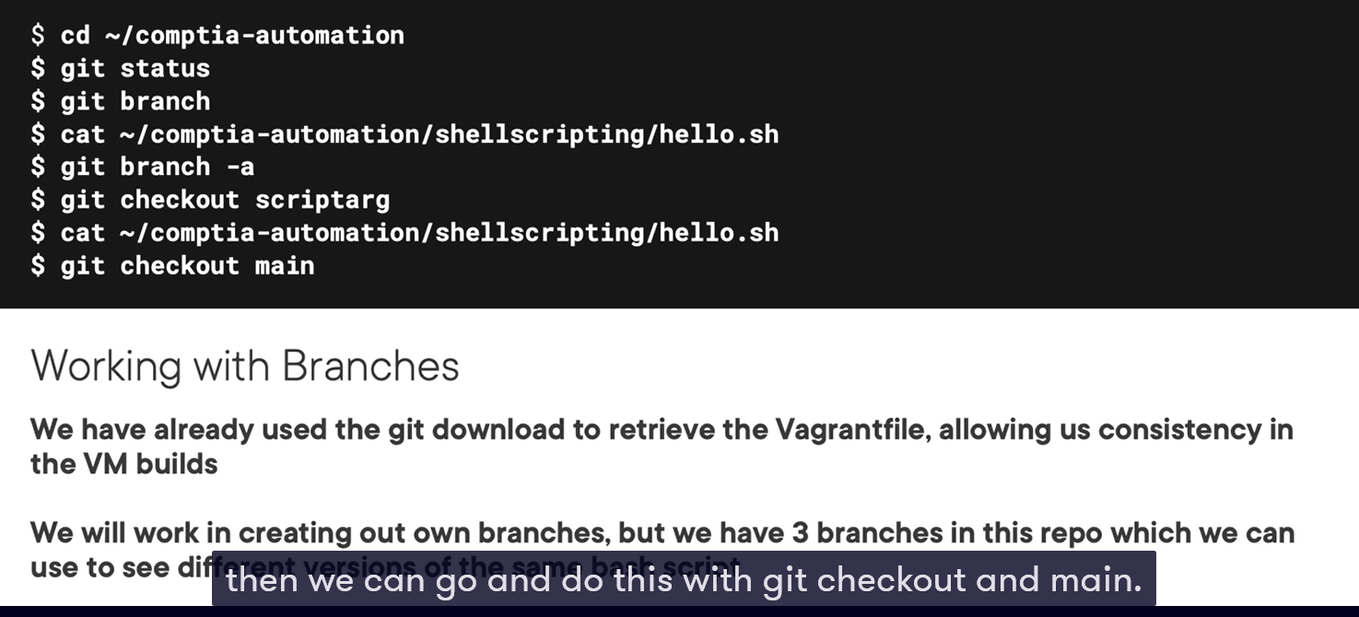

## Chapter 2.4: Adding Global Configuration

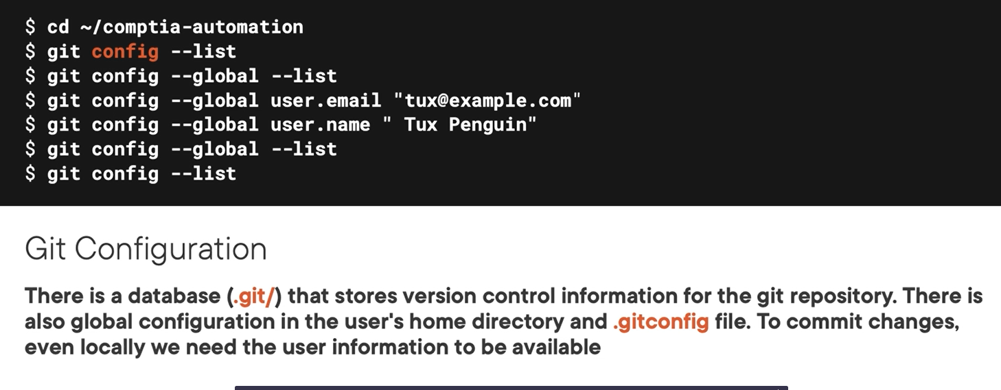

## Chapter 2.5: Understanding Git Repos and How to Revert Code

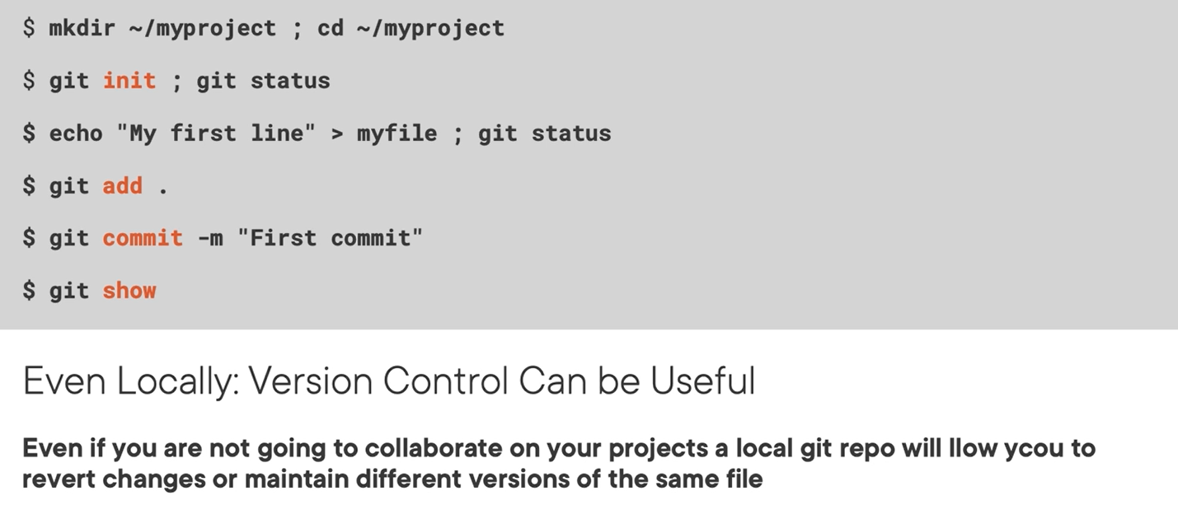

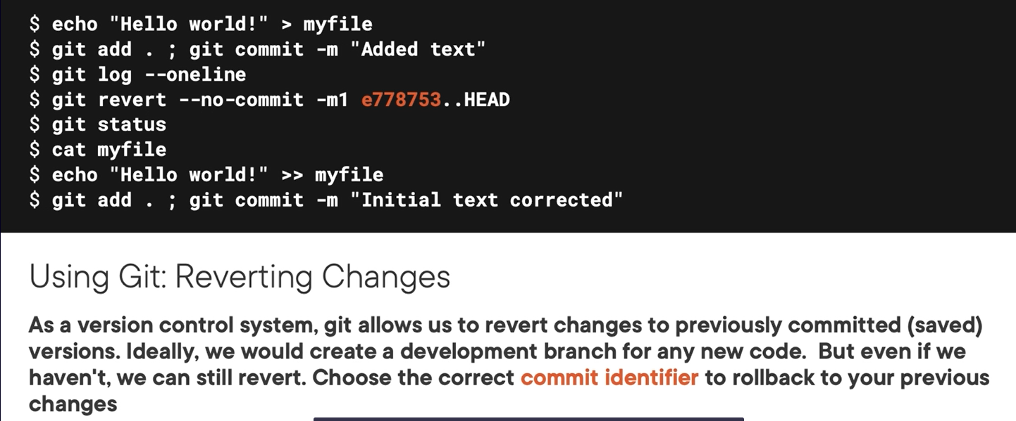

## Chapter 2.6: Creating a New Repository

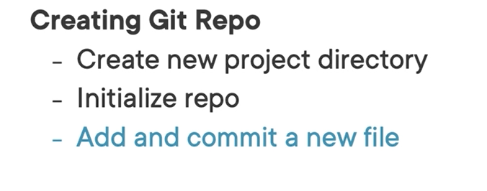

Add, without save and rm cached from working stage on git

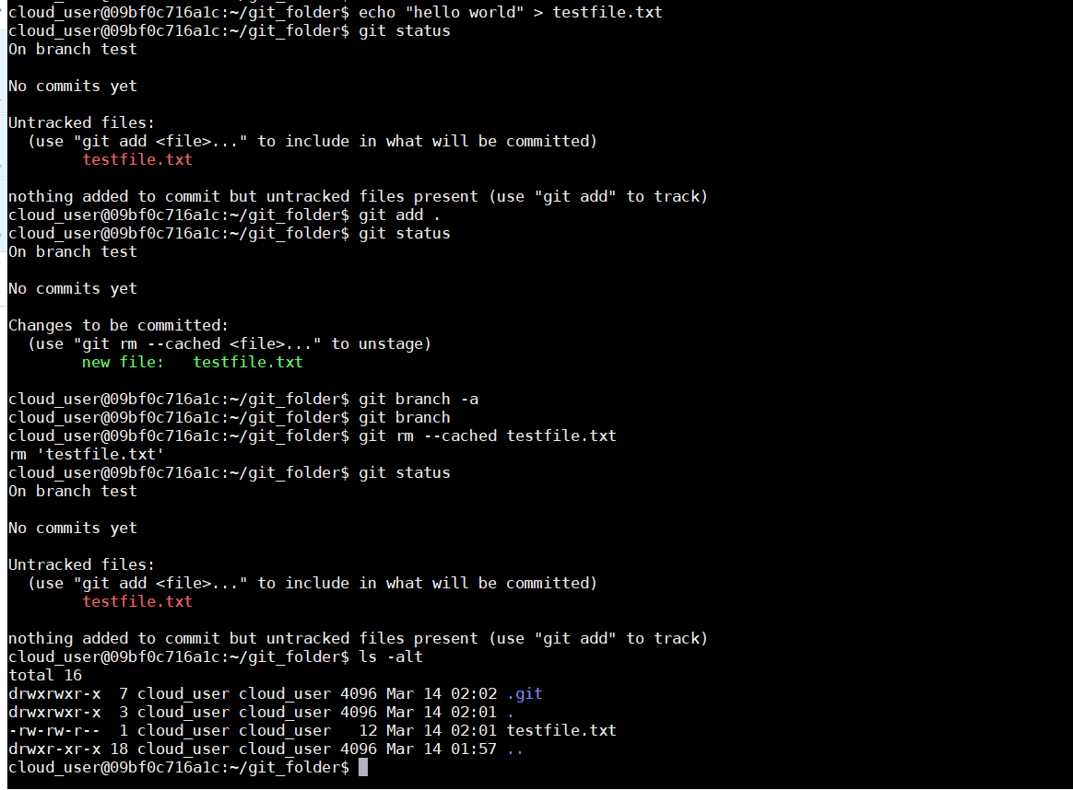

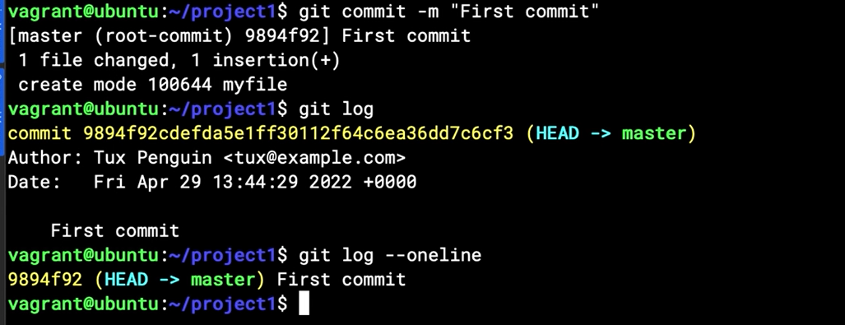

## Chapter 2.7: Reverting Code Changes

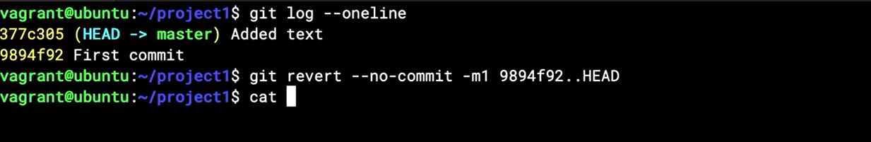

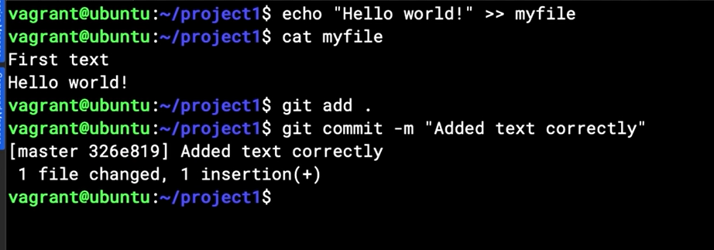

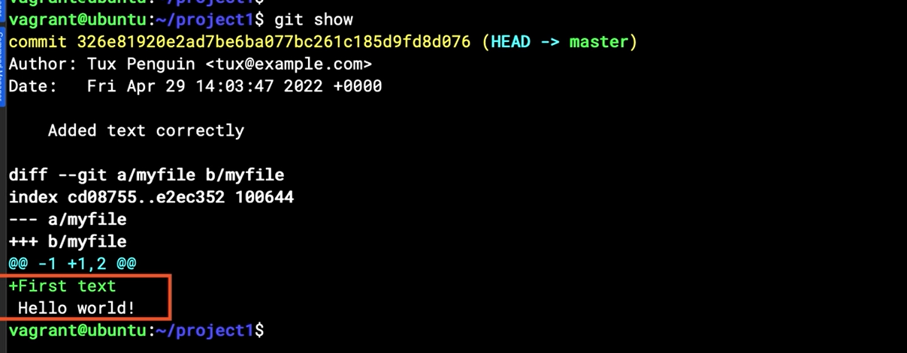

## Chapter 2.8: Implementing gitignore

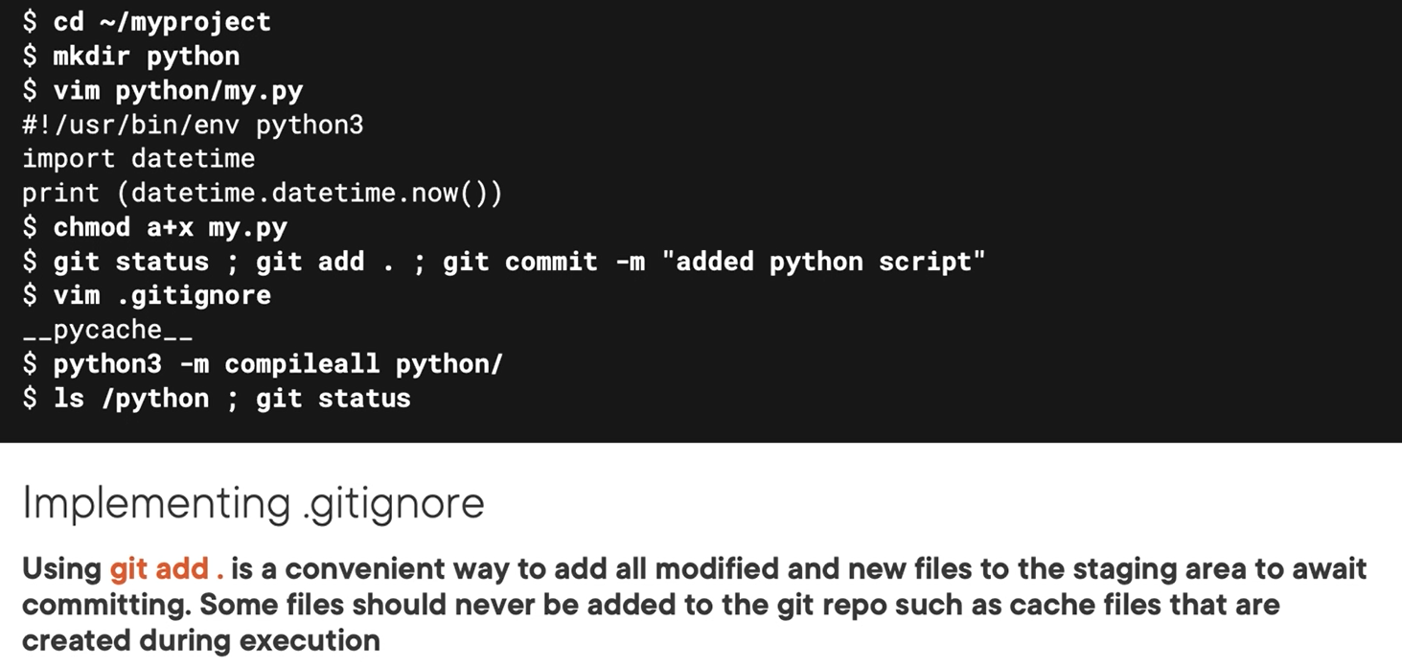

# Vi .gitignore

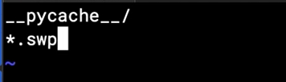

Note: __pycache__/ “ dau / cho biet no la thu muc”

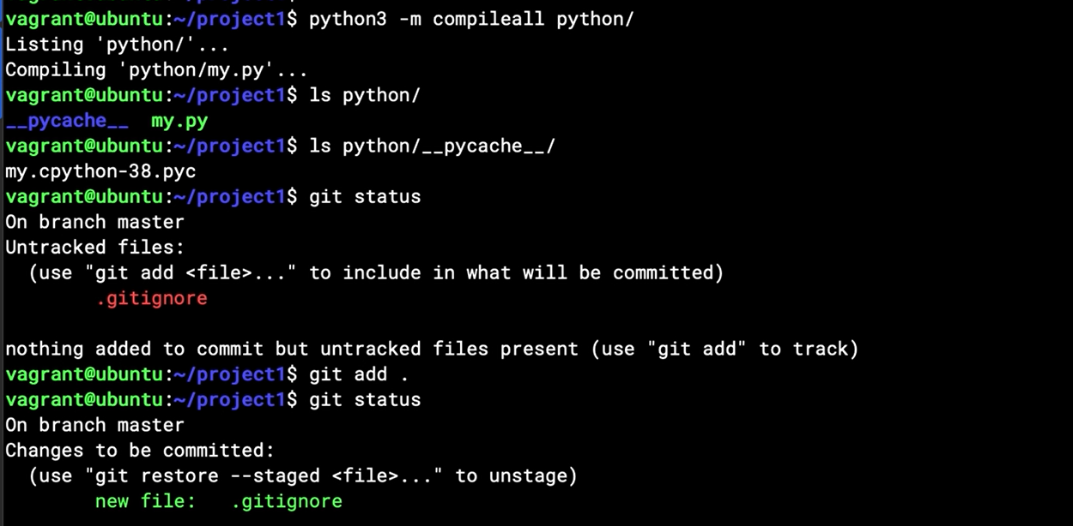

## Chapter 2.9: Understanding Remote Repos

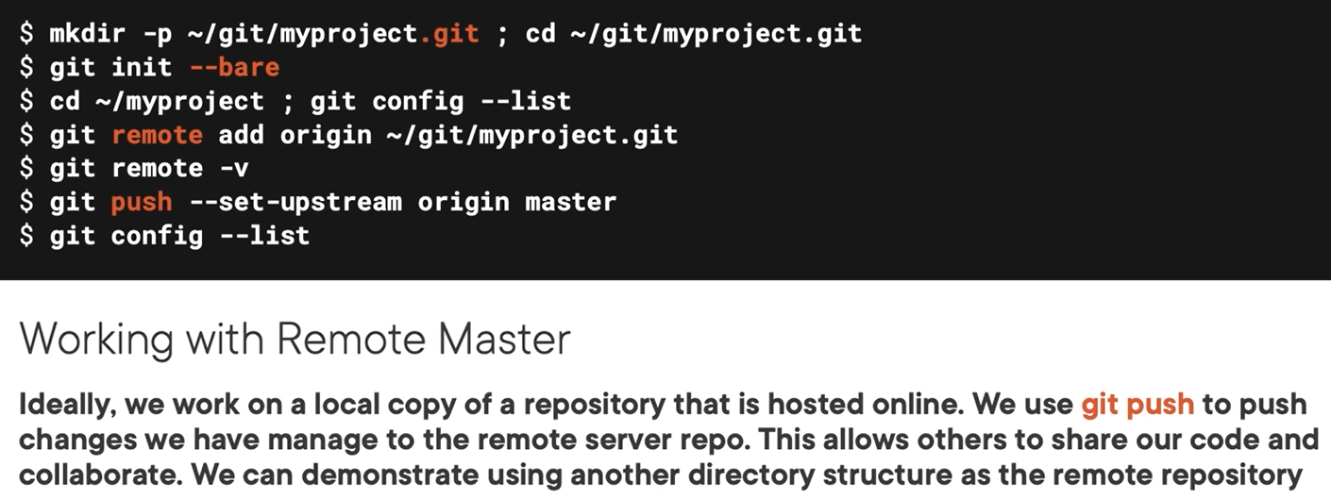

## Chapter 2.10: Adding a New Remote Repo

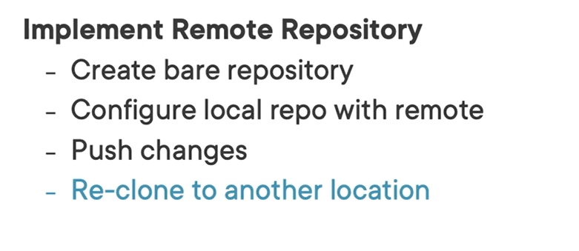

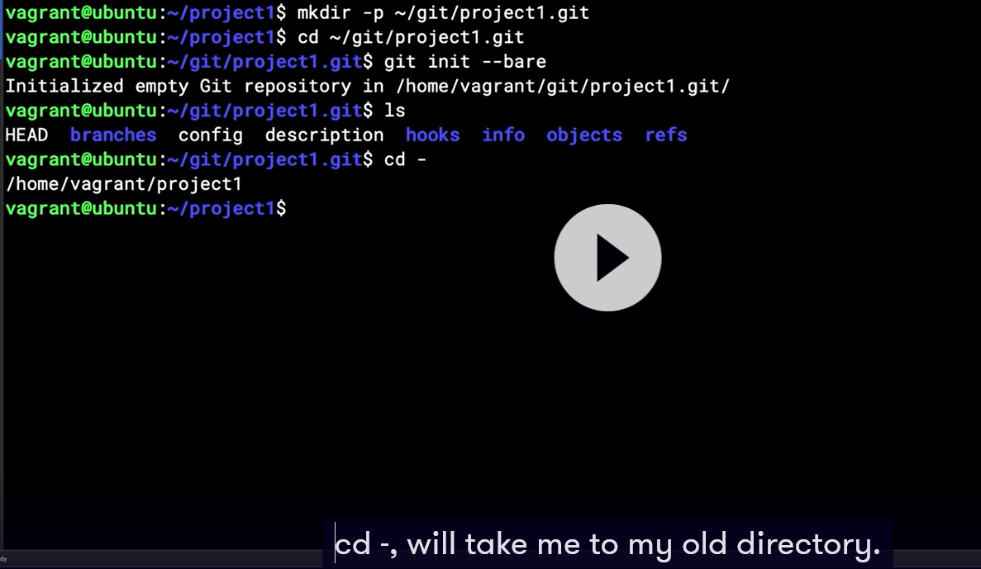

Add remote repo

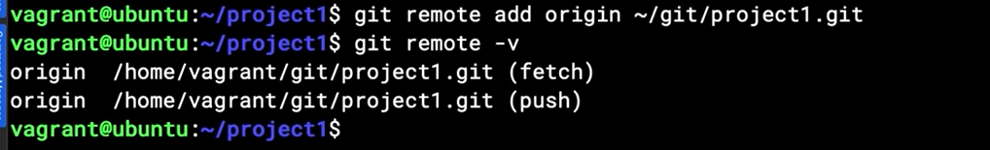

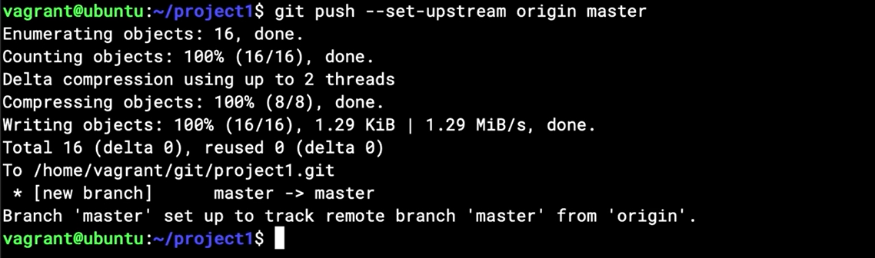

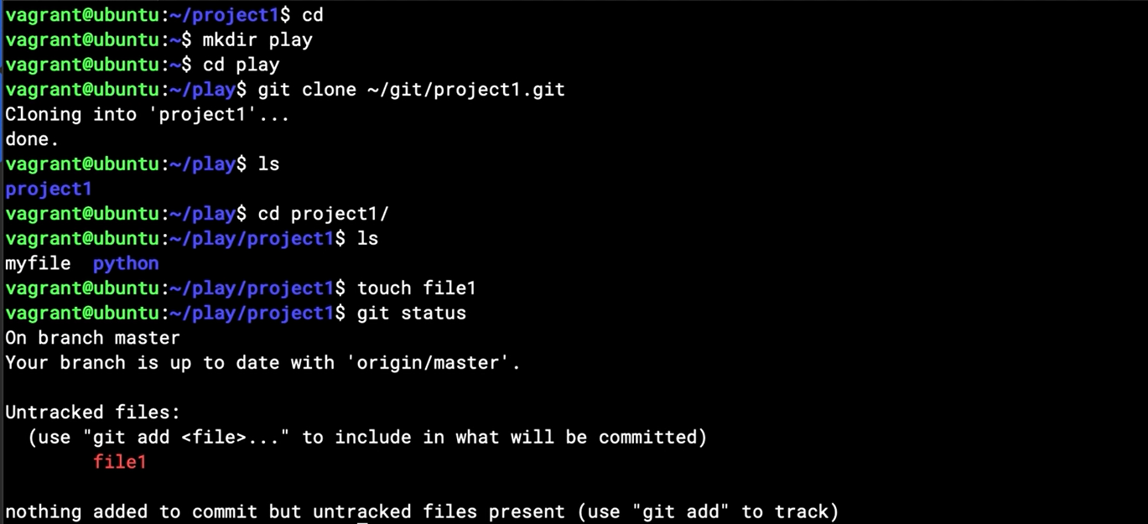

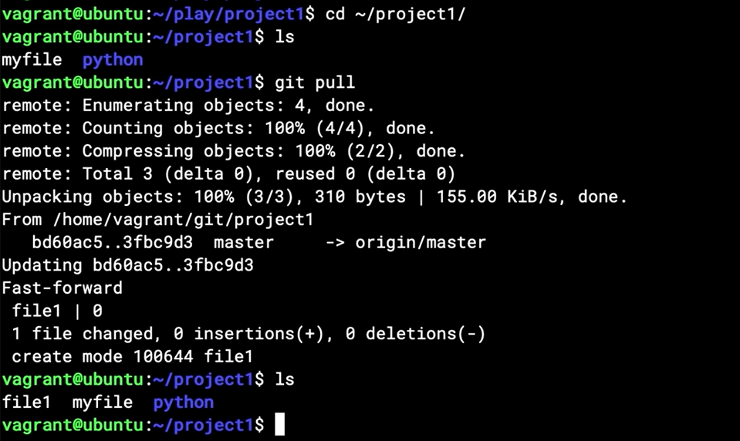

## Chapter 2.11: Merging Branches

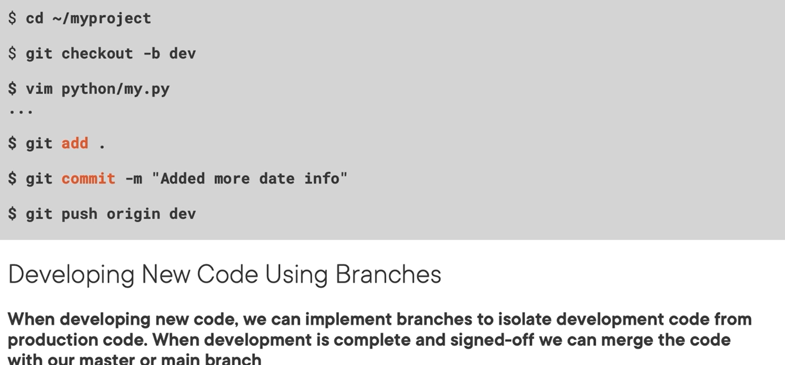

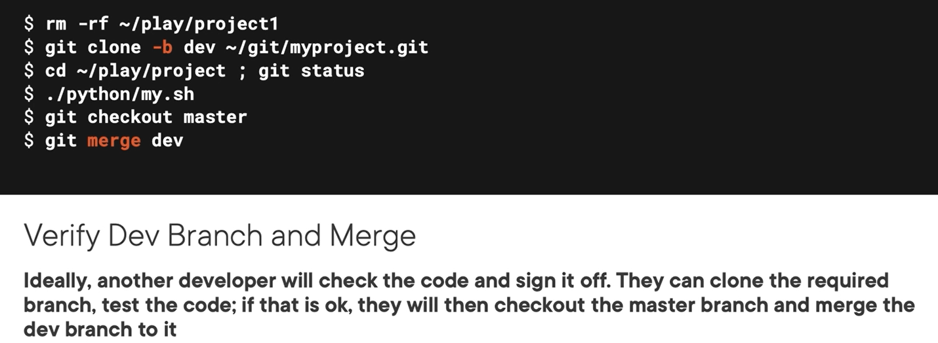

# Chapter 3: Implementing Linux Automation Using Shell Scripts

## Chapter 3.1: Using Shell Script Automation

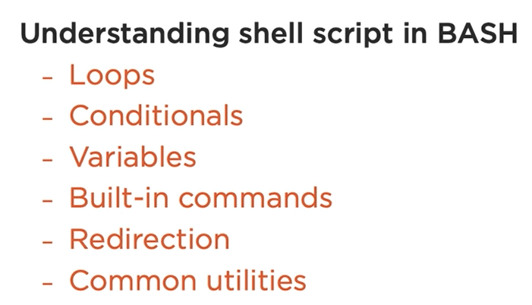

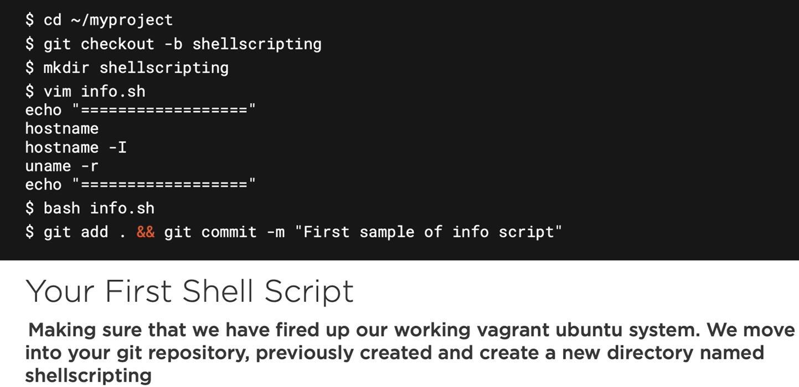

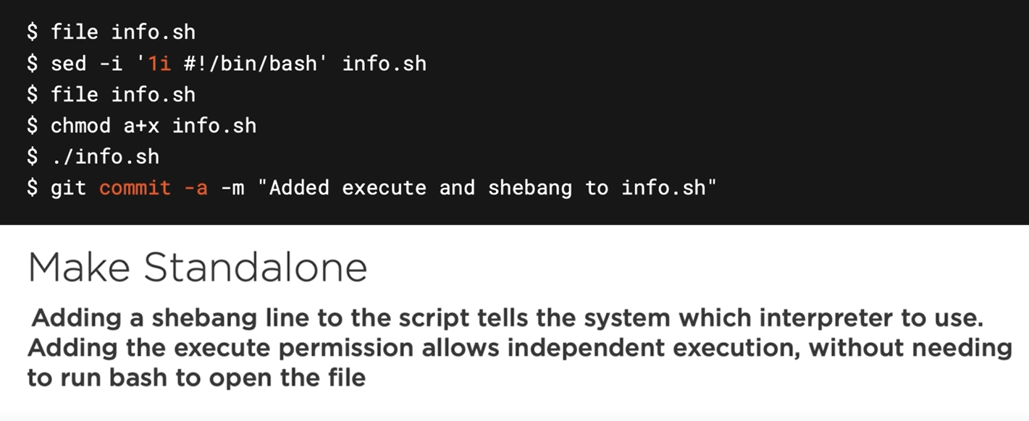

## Chapter 3.2: Creating a Basic Sysinfo Script

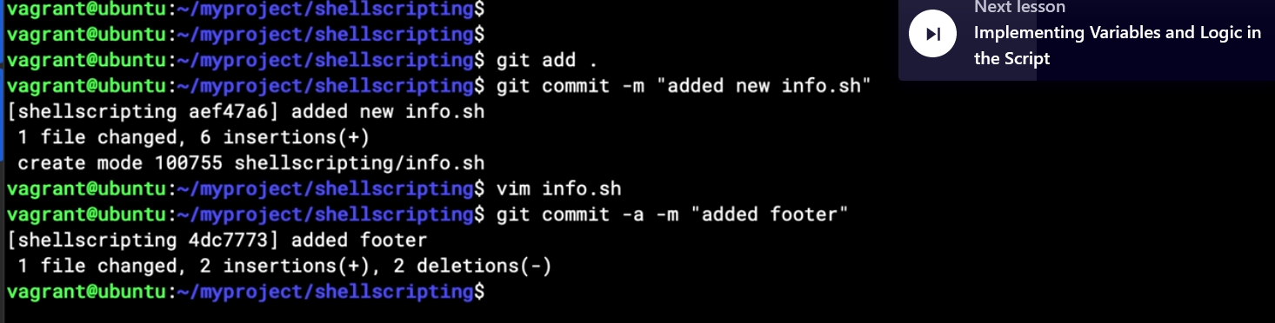

## Chapter 3.3: Implementing Variables and Logic in the Script

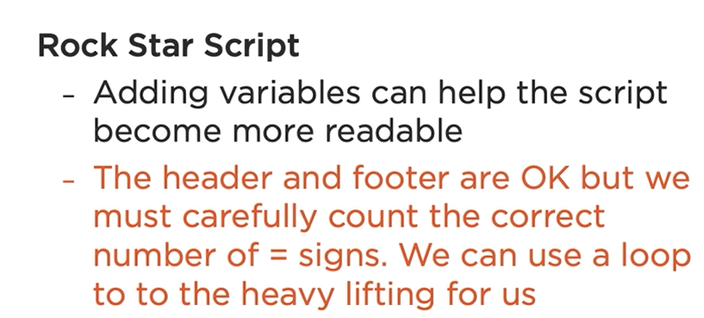

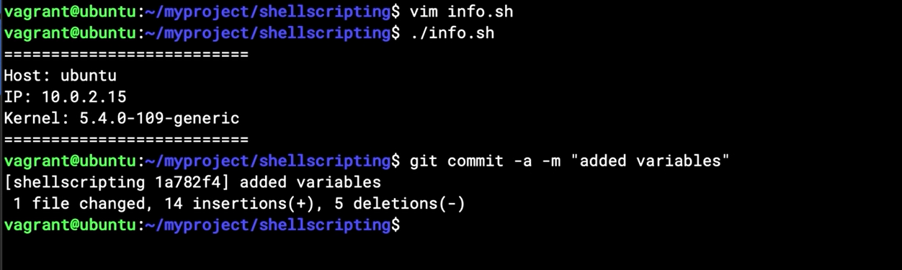

## Chapter 3.4: Source Variables from et/cos-release

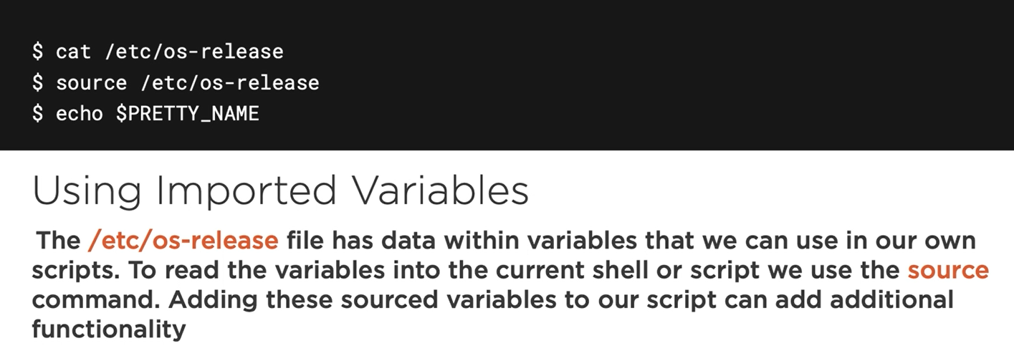

To using all variables in this folder, you could use “source” command

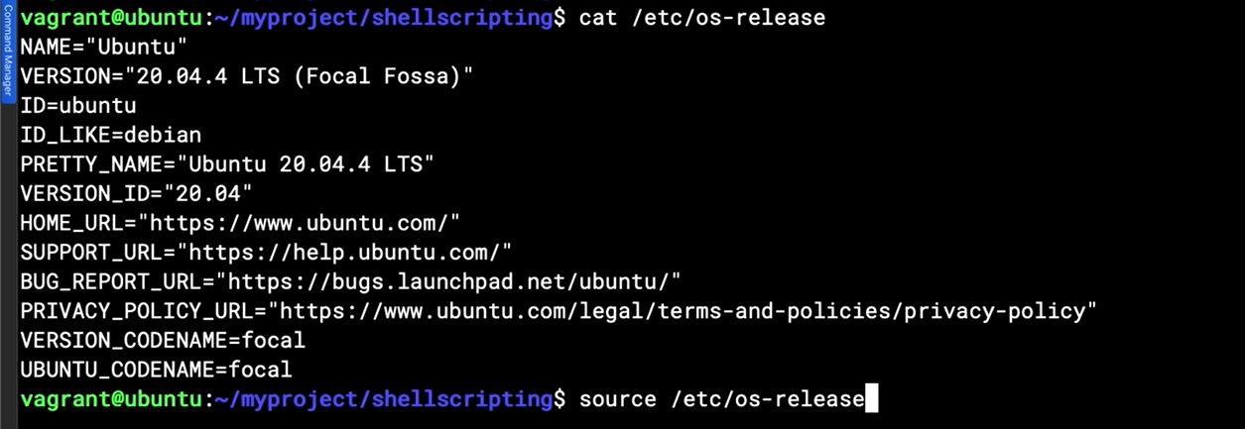

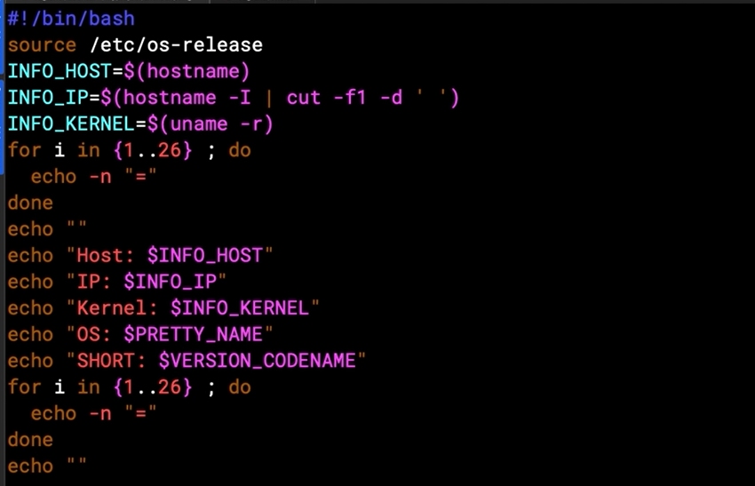

## Chapter 3.5: Creating a Password Generator

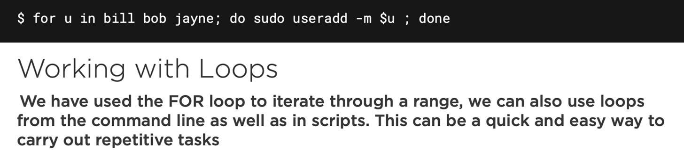

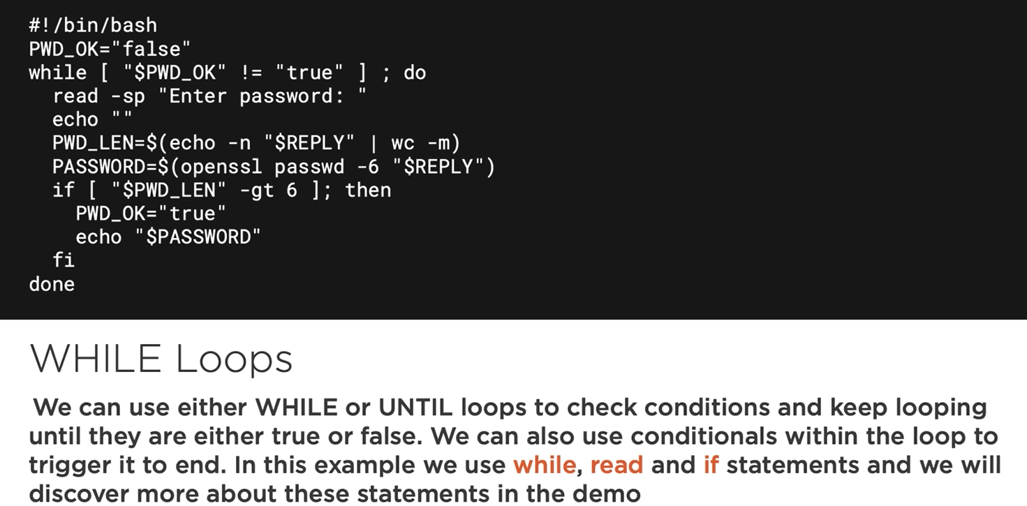

demo

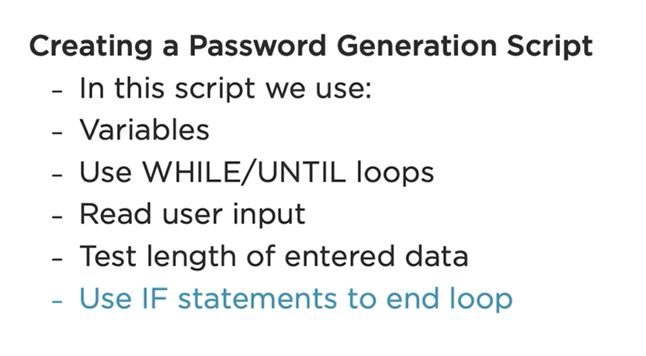

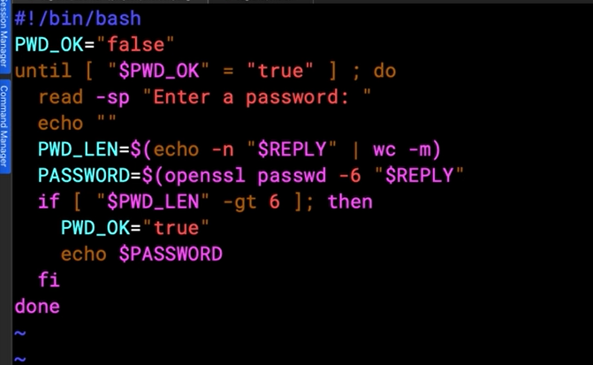

## Chapter 3.6: Improving Password Generation

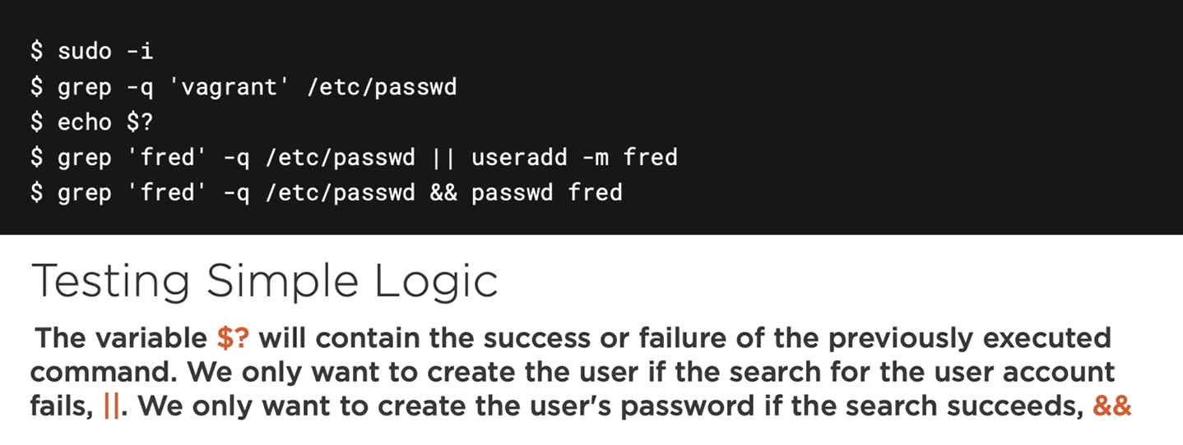

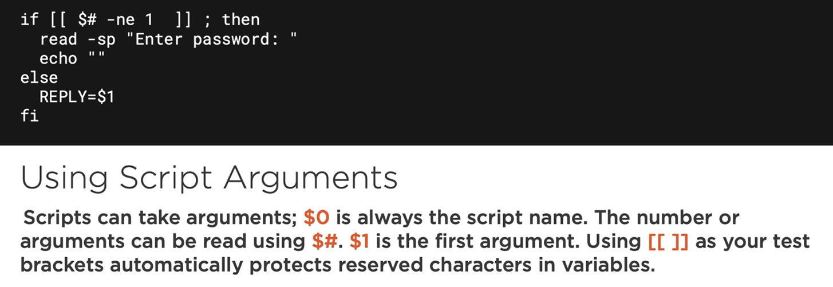

Note: using double square brackets very convenient, it usefull when go to through and use variables without quoting them. It means variable can content special character wont cause any problem.

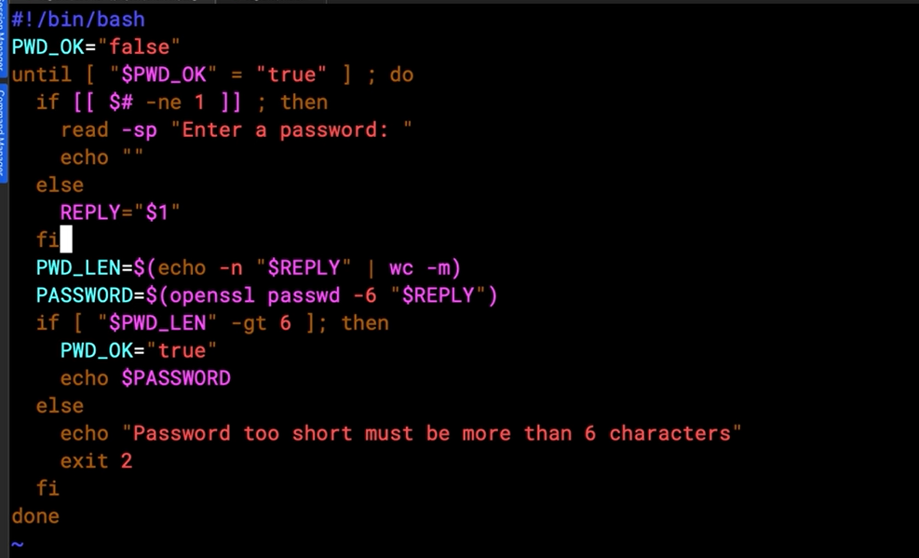

## Chapter 3.7: Scripting User Creation

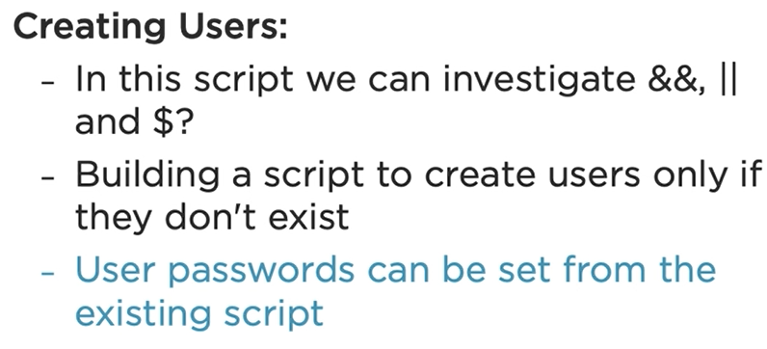

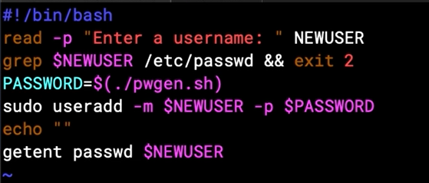

## Chapter 3.8: Introduction the Power of AWK

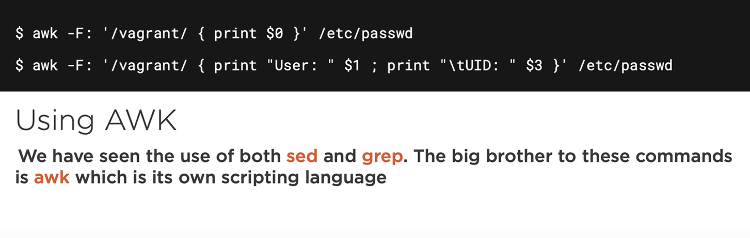

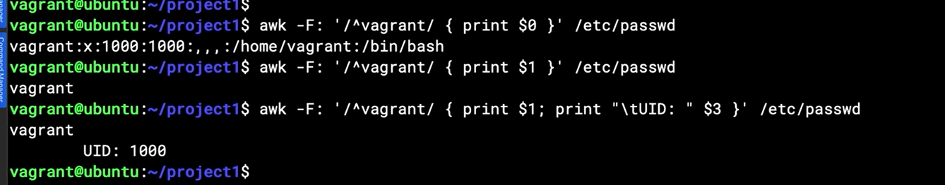

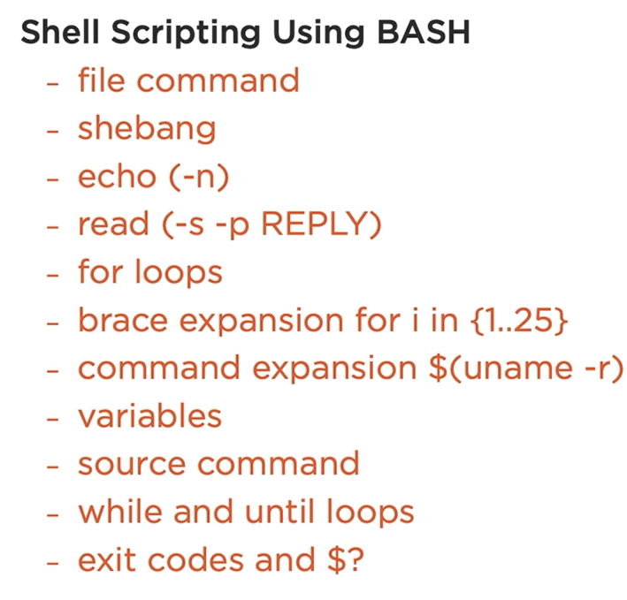

# Chapter 4: Implementing Configuration Management and IaC

## Chapter 4.1: What is IaC

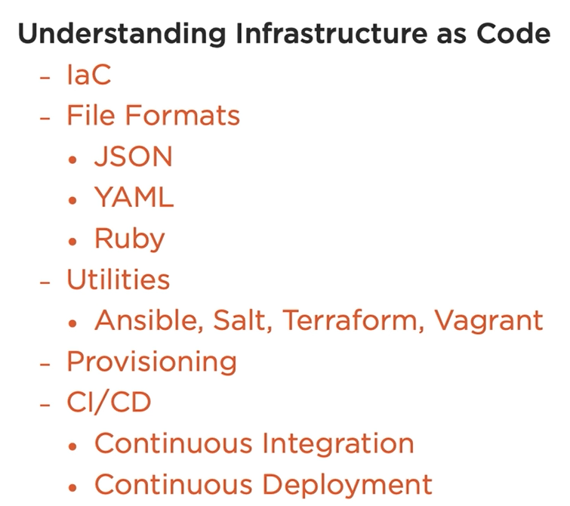

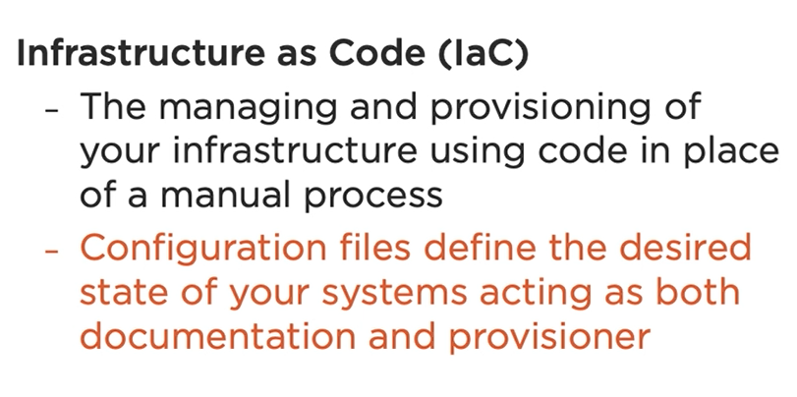

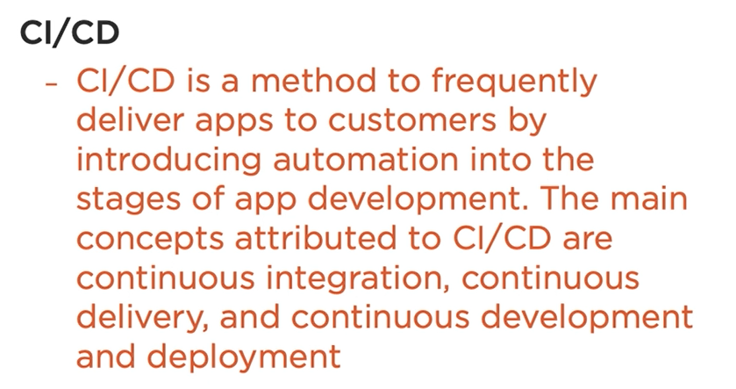

Some type of files we will need:

Yaml: ansible, salt

Ruby: vagrant, chef, puppet

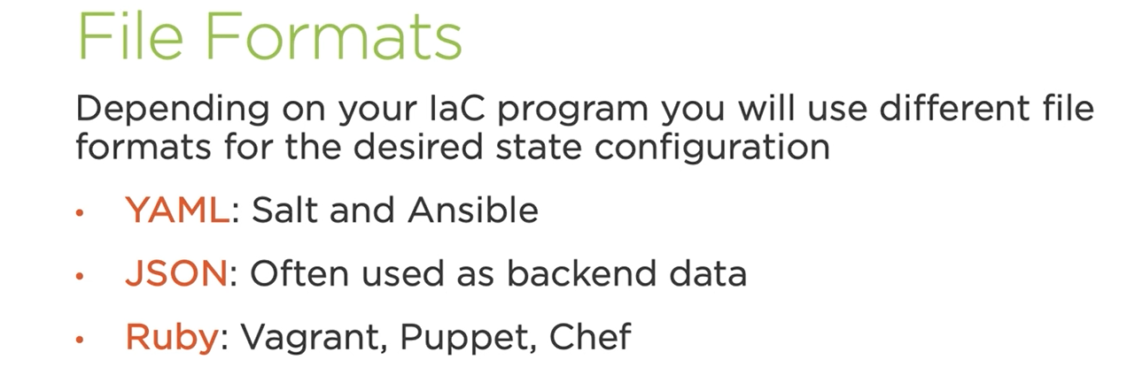

Vagrant

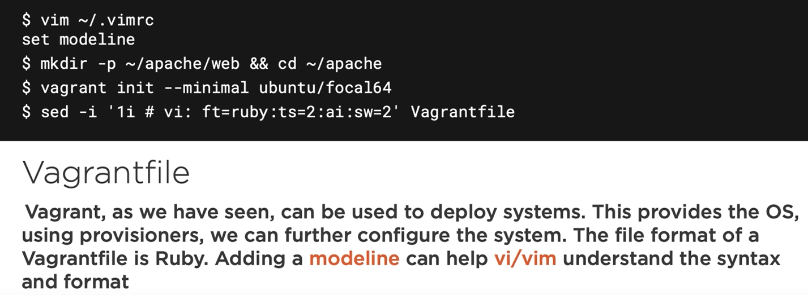

## Chapter 4.2: Syntax Control Using Modeline in Vim

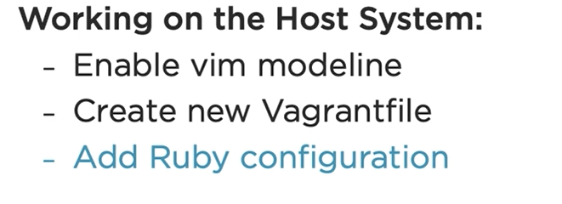

Set dark color on screen terminal

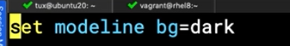

Init or create vagrant file

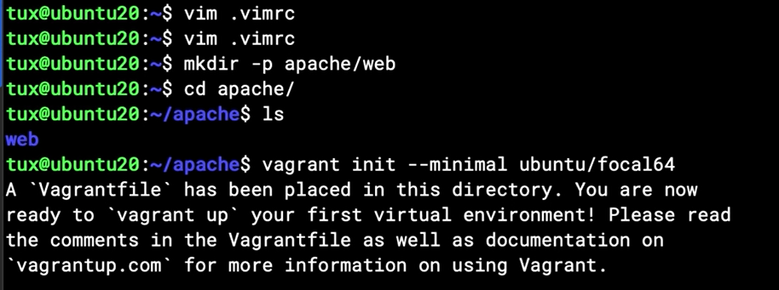

Vi vagrant file

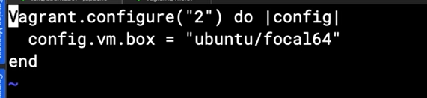

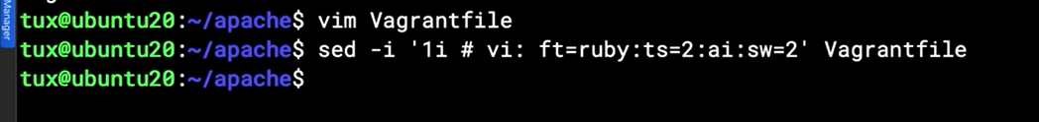

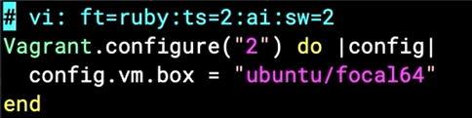

Note: shift + A for move to the end of current line

## Chapter 4.3: Understanding Vagrant Provisioning

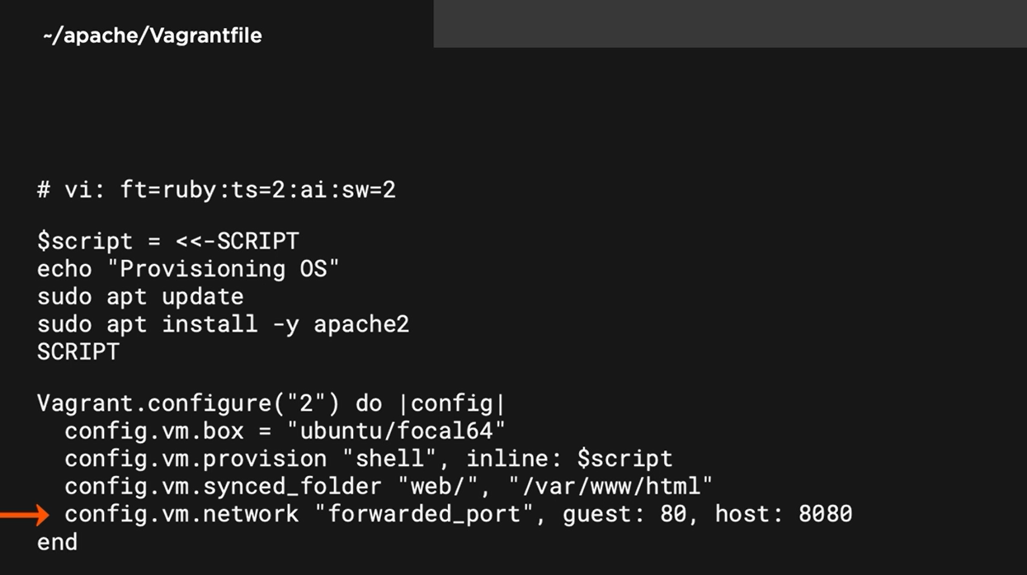

Note: “inline” indicate that the $script will be used inside the file

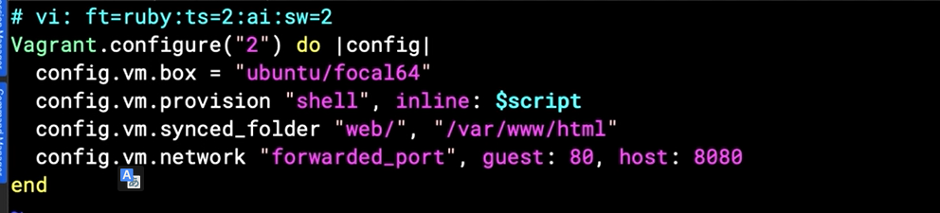

## Chapter 4.4: Provisioning an Apache Web Server

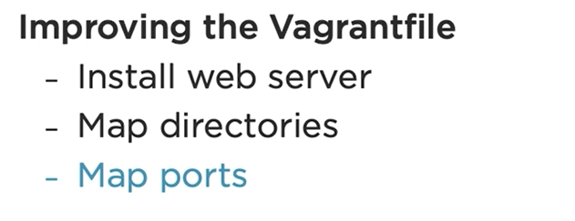

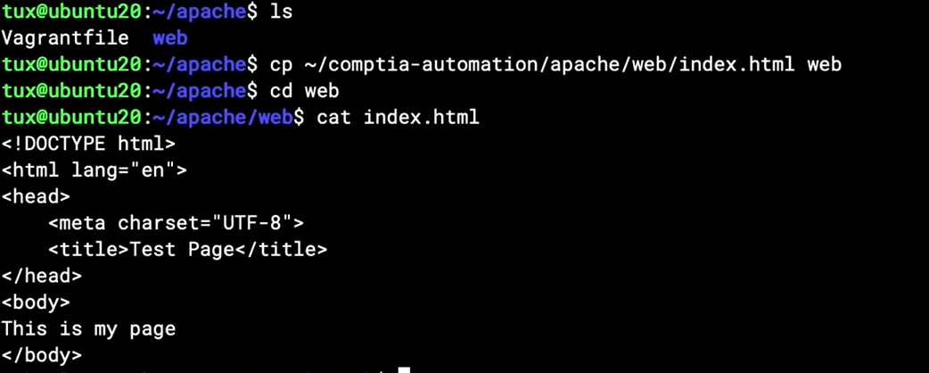

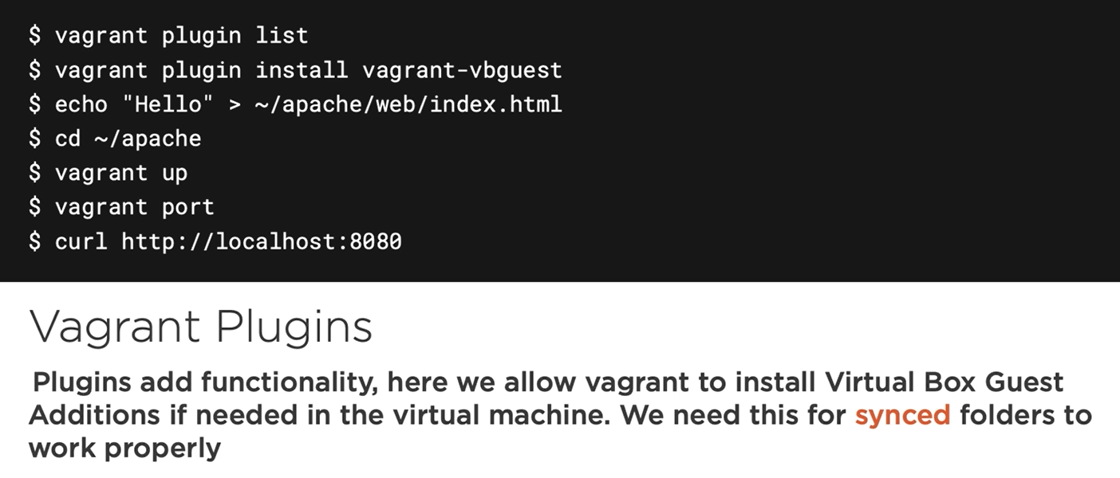

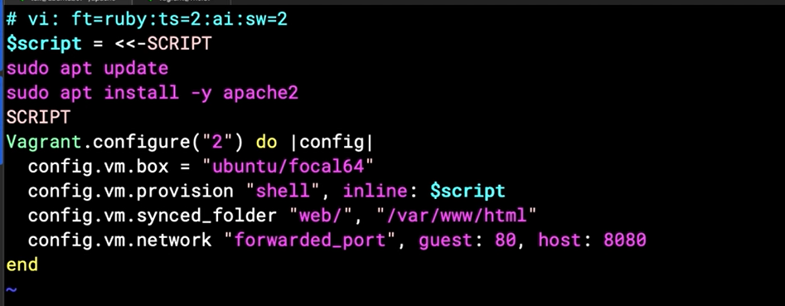

Install vbguest plugin for all guest machine sync to host folder

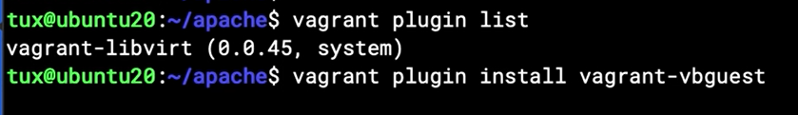

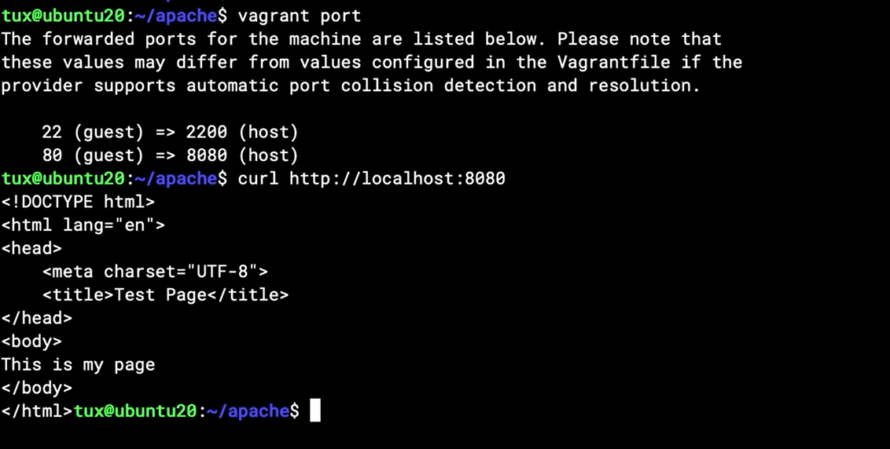

## Chapter 4.5: Writing YAML

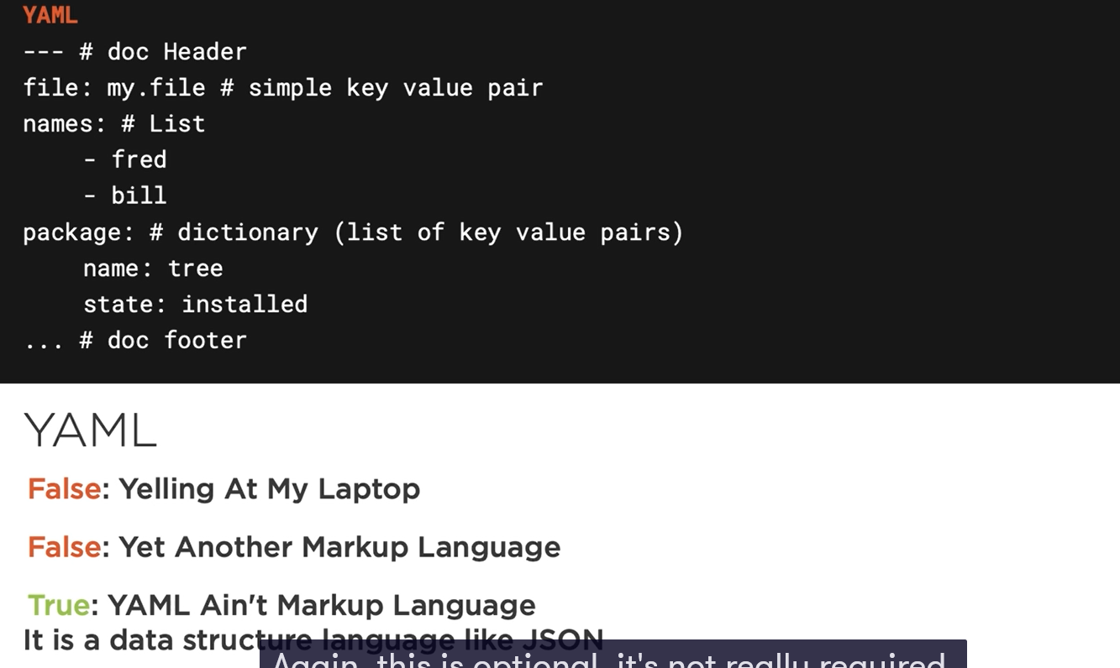

Demo

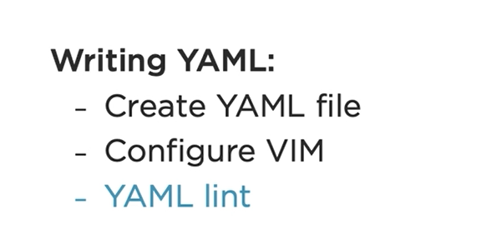

Note: not using tab



Note: cuc: column highlighting; cul: underline highligting

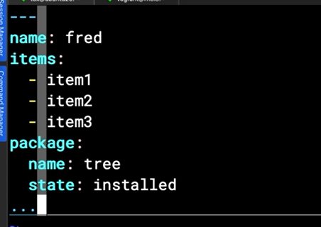

You should install yamllint validator

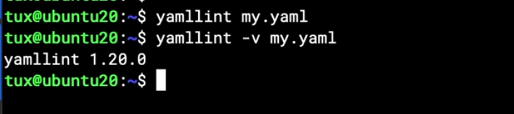

## Chapter 4.6: Comparing YAML and JSON

Json: java script object notation 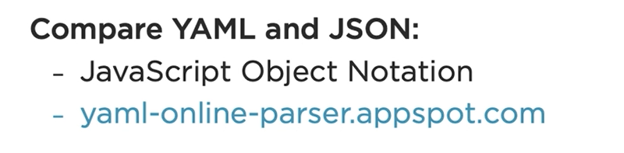

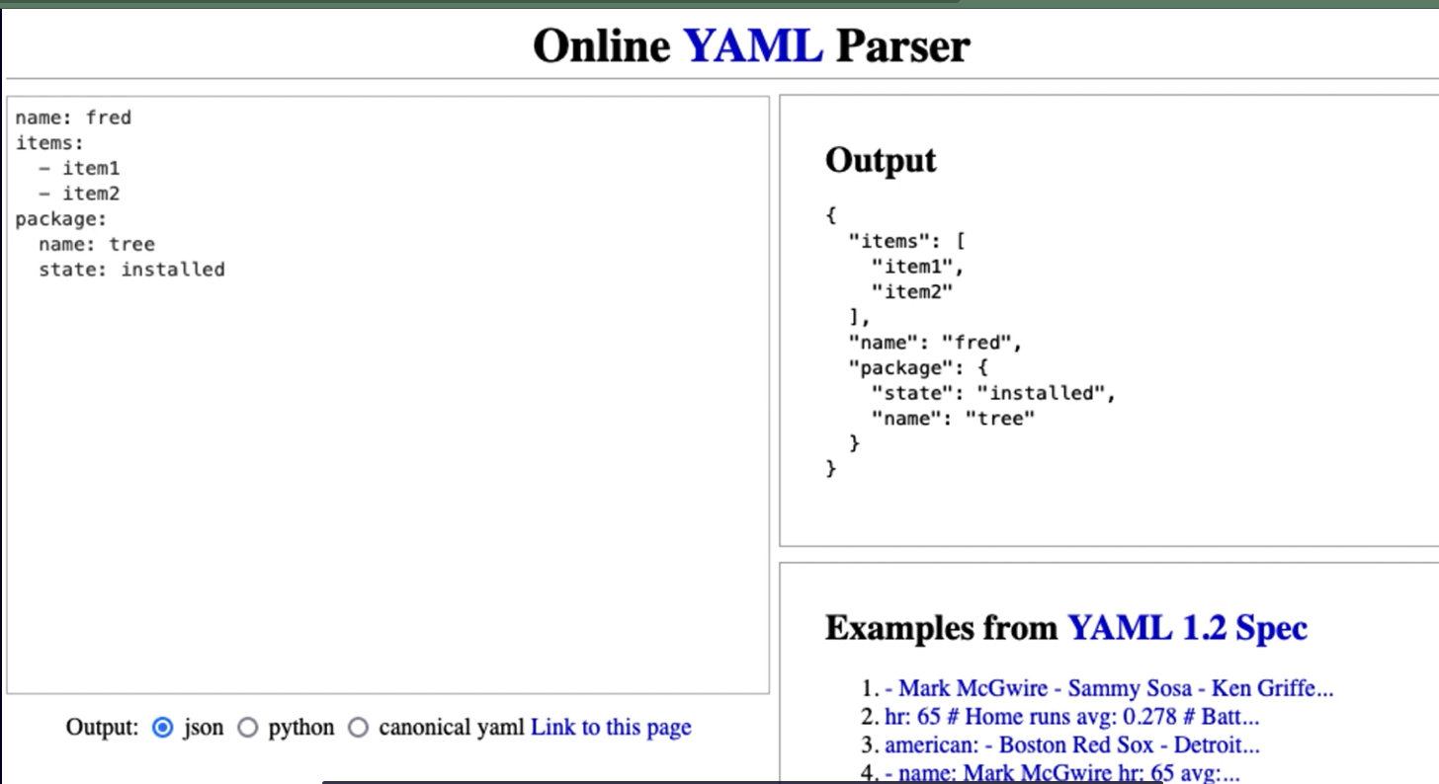

# Chapter 5: Implementing Ansible for Configuration Management

## Chapter 5.1: Introduction to Ansible

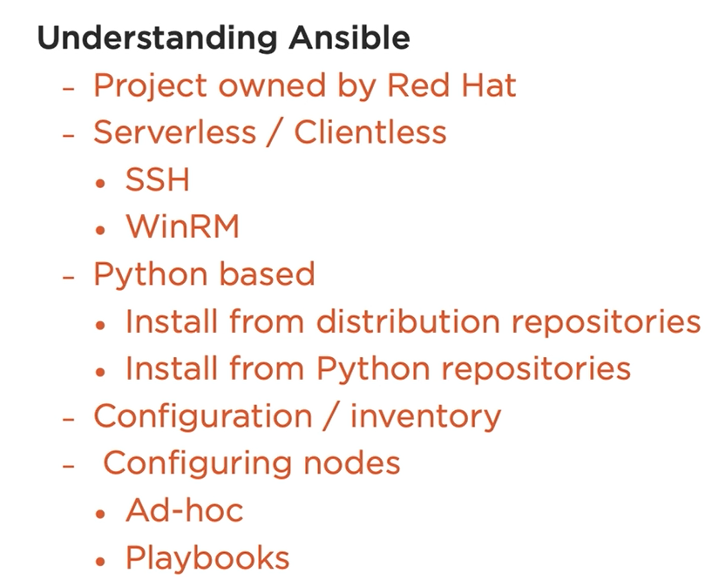

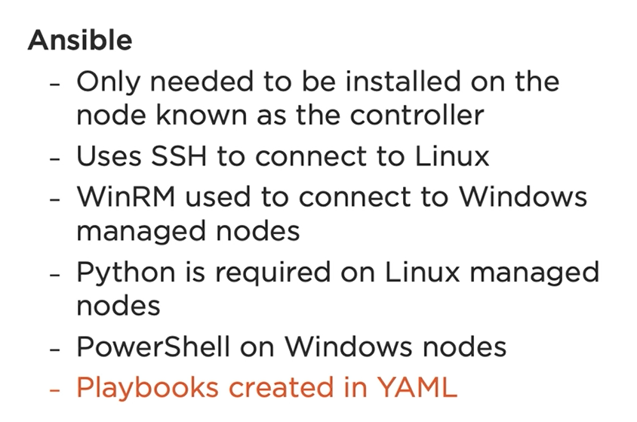

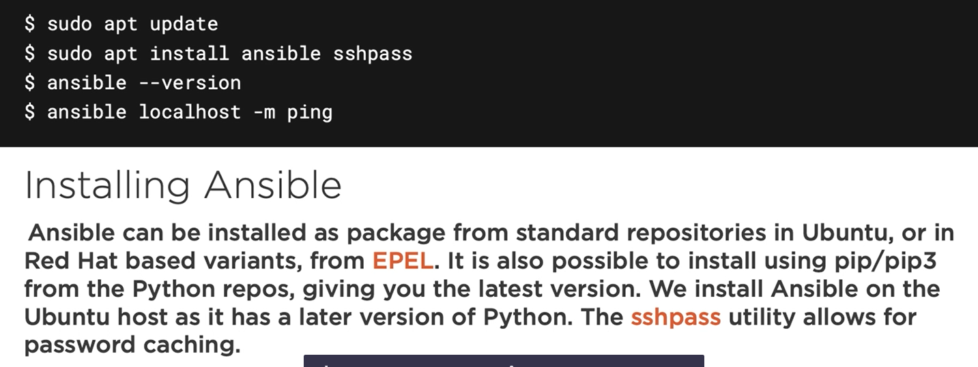

Note: sshpass will cache password

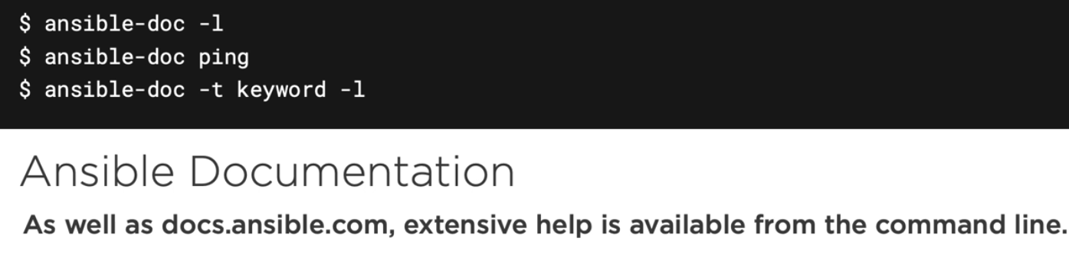

## Chapter 5.2: Installing Ansible



## Chapter 5.3: Understanding Ansible Configuration and Inventory

You can create another ansible directory and configuration file must be resident within that directory where the commands being executed.

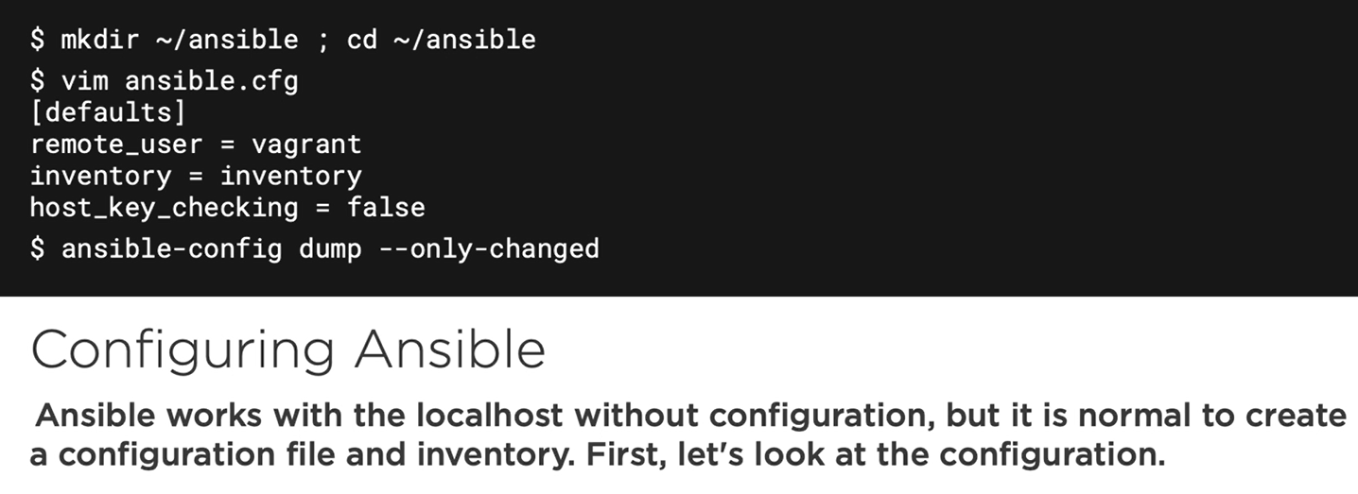

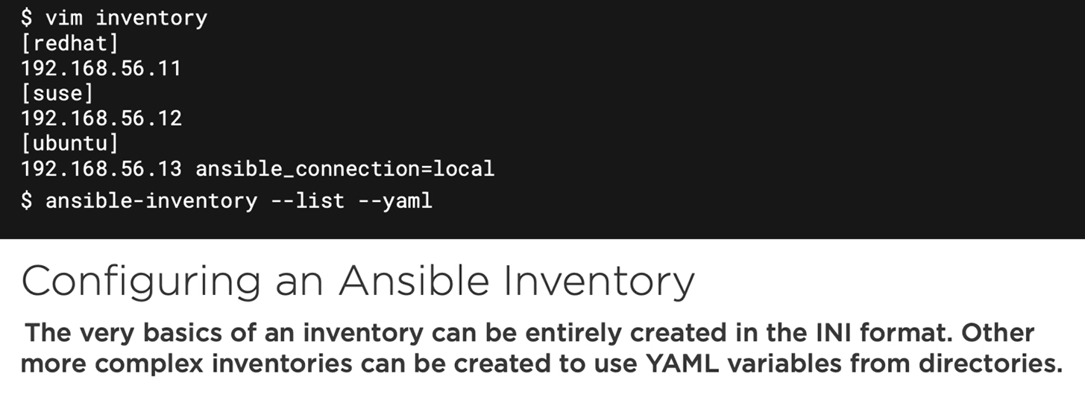

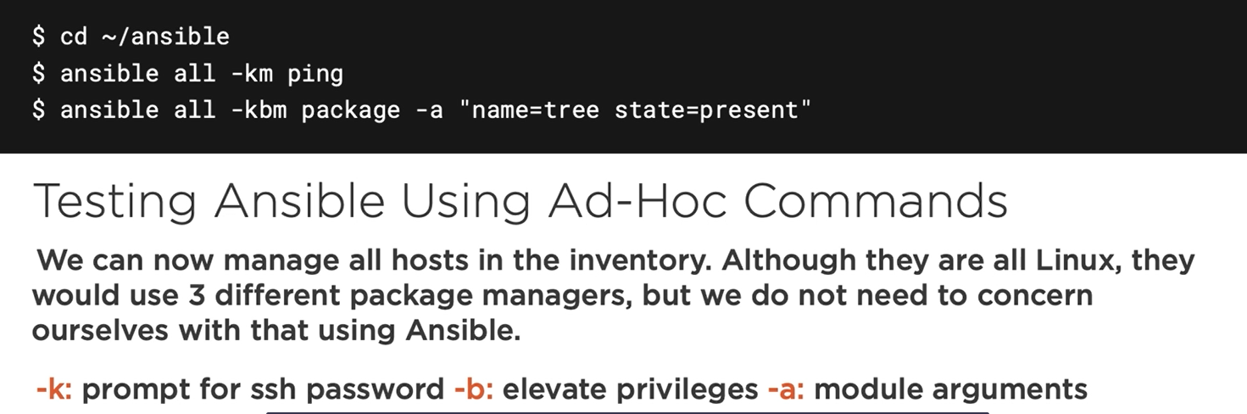

## Chapter 5.4: Creating Ansible Configurations and Inventory

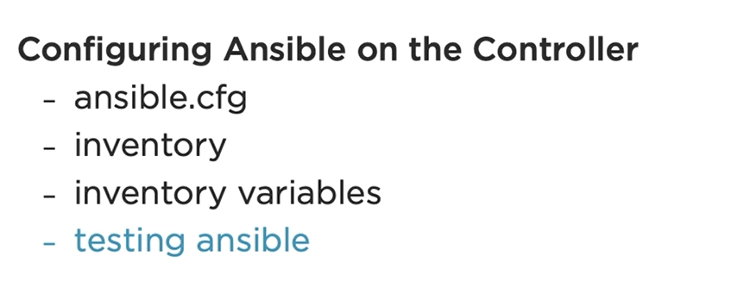

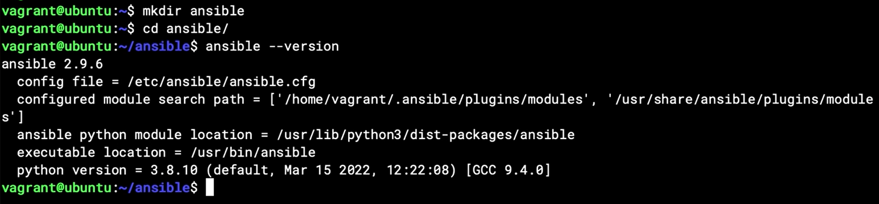

Checking default configuration of ansible :

ansible-config dump –only-changed

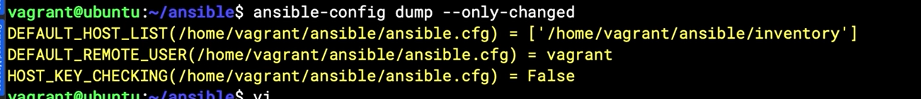

Inventory file at INI format

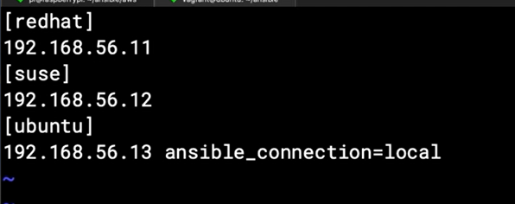

Checking inventory

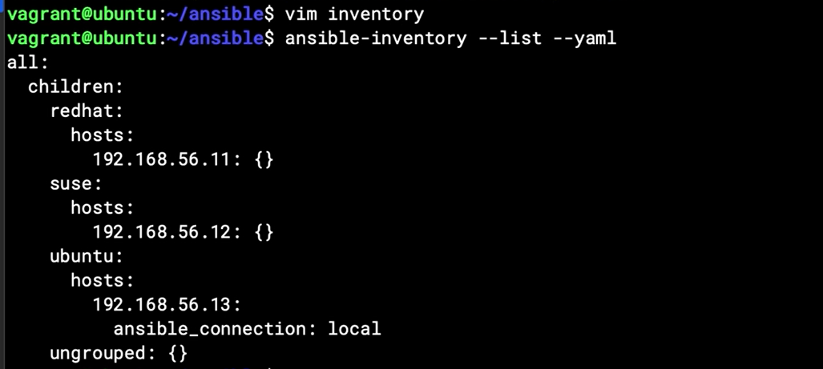

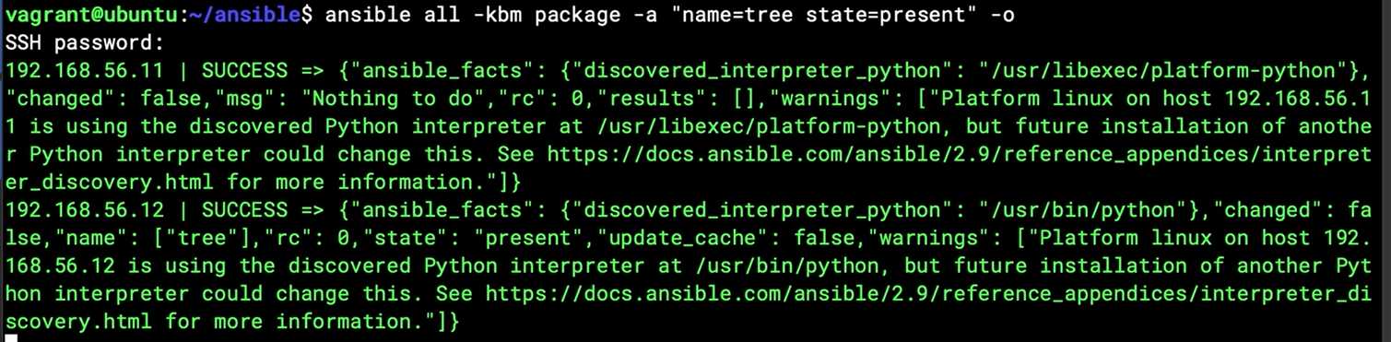

## Chapter 5.5: Implementing Ansible Playbooks

Creating a playbook; consist of many play

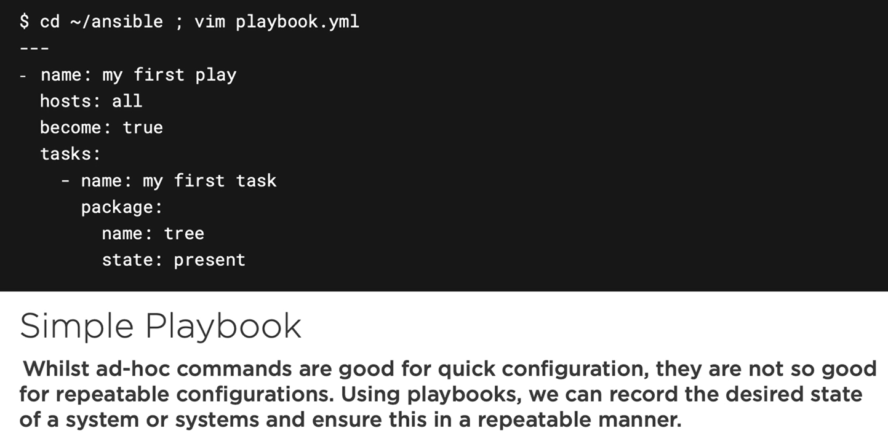

Run playbook with option -C (just checking operation without running)

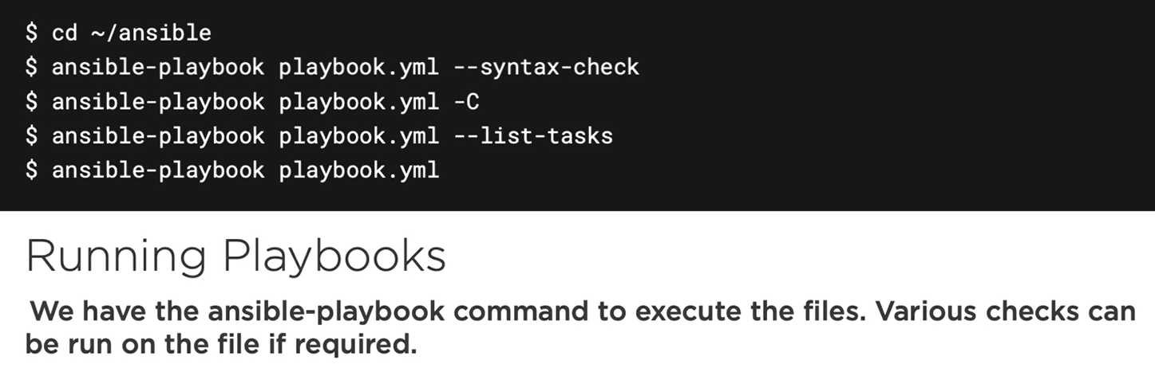

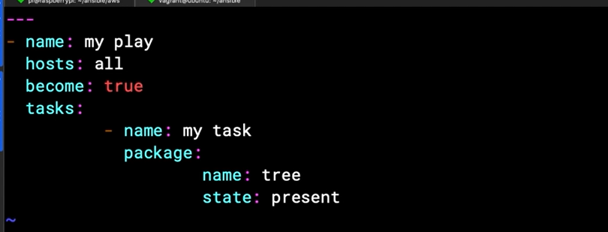

Checking with cat command option -vet with end character is $ (without printing)

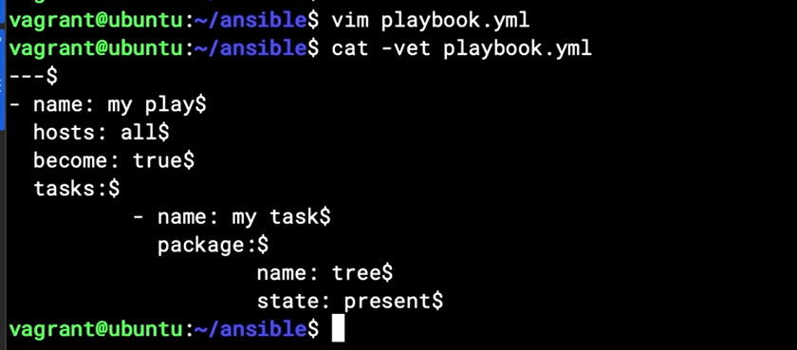

## Chapter 5.6: summary

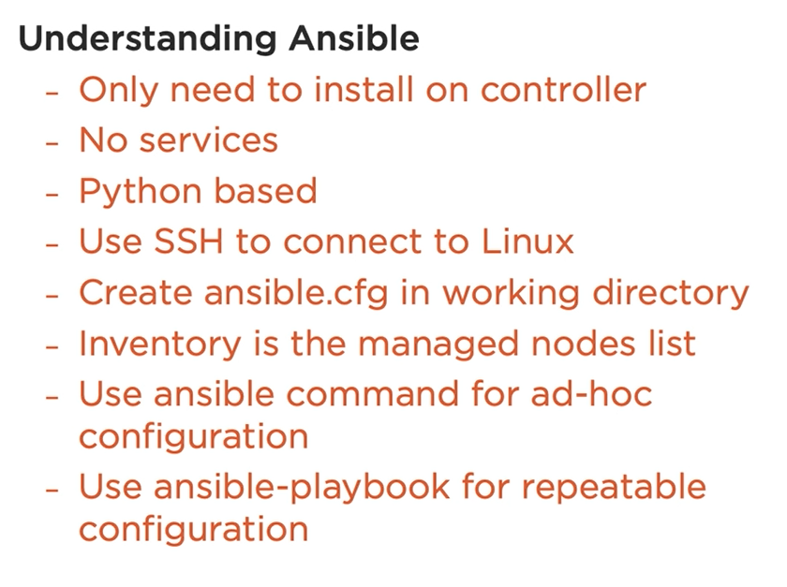

# Chapter 6: Implementing Puppet for Configuration Management

## Chapter 6.1: Welcome to Puppet

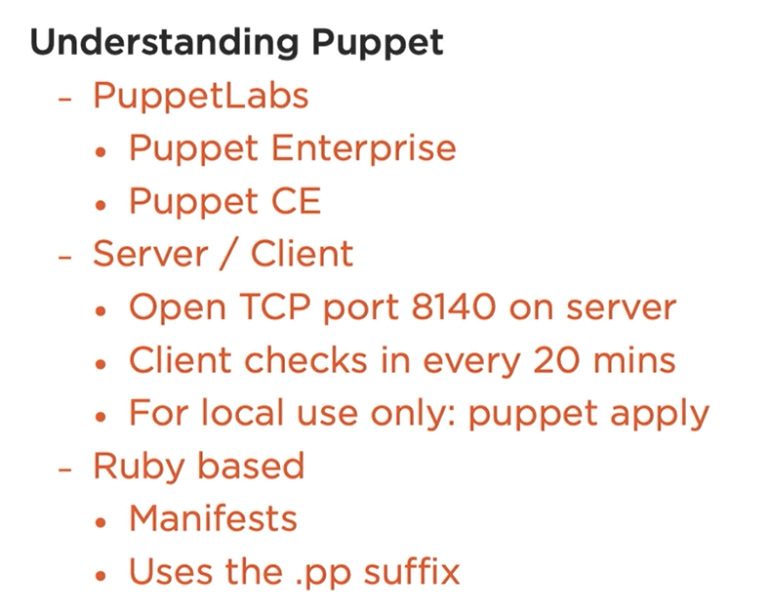

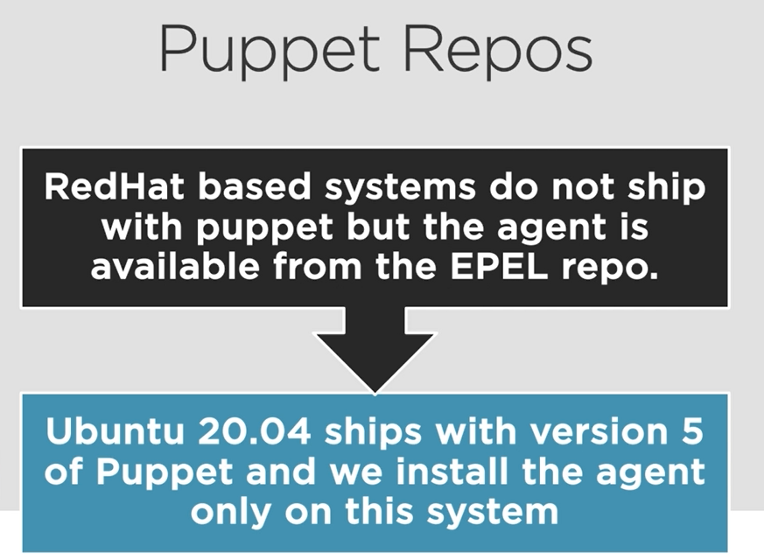

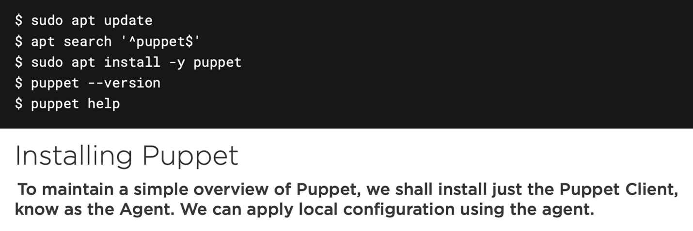

## Chapter 6.2: Installing Puppet on Ubuntu

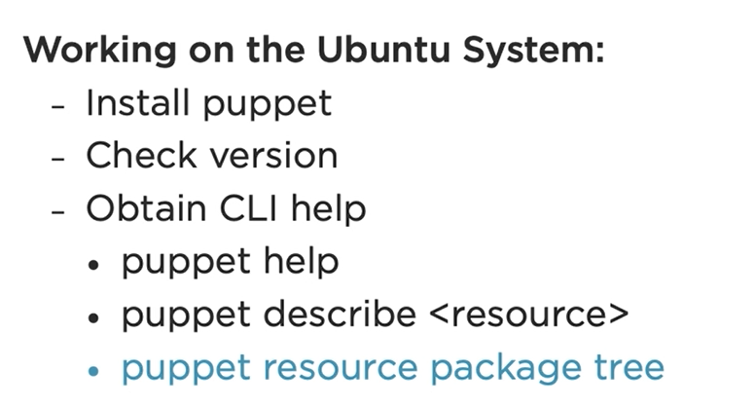

## Chapter 6.3: Executing Ad Hoc Puppet Commands

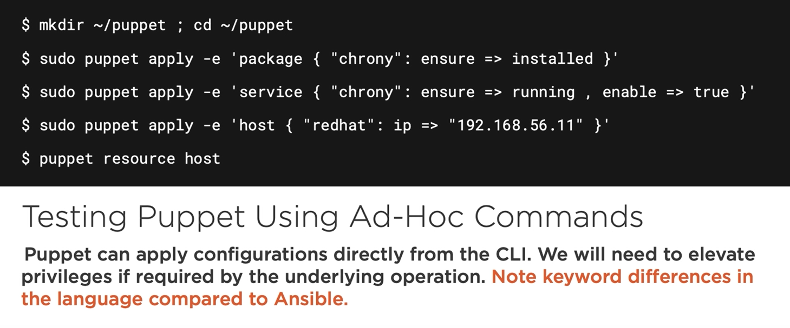

Demo

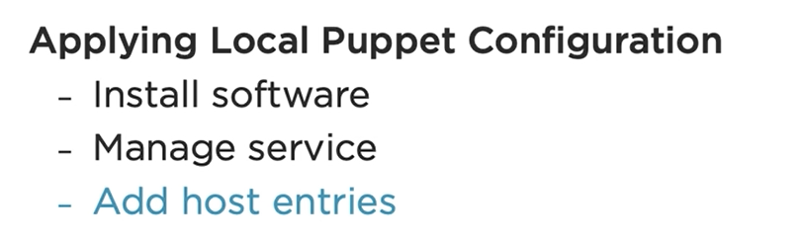

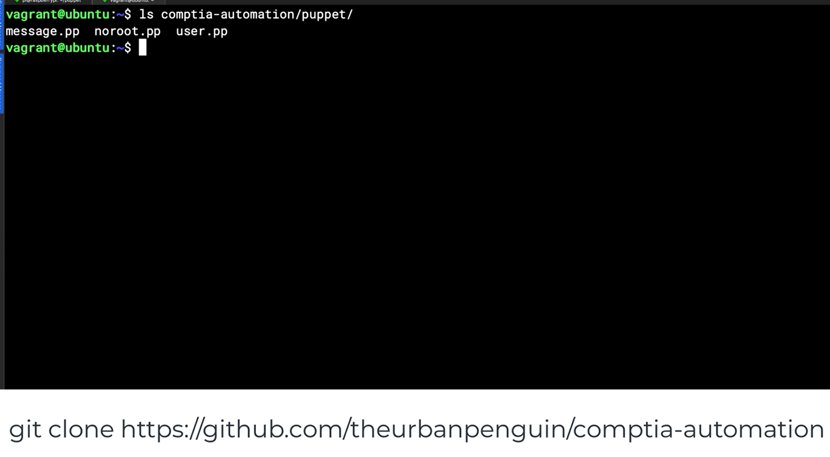

<https://github.com/theurbanpenguin/comptia-automation>

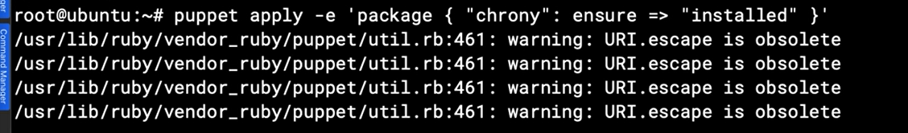

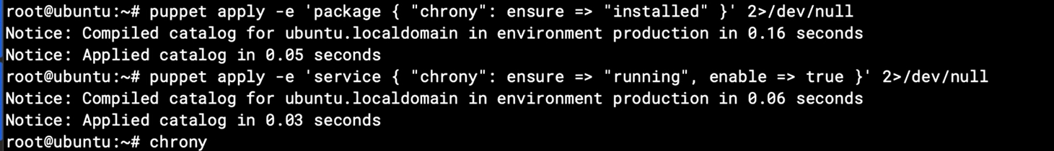

Check chrony package is installed and check service is running

Puppet apply -e ‘package {“chrony”: sure => “installed}’

Puppet apply -e ‘service {“chrony”: sure => “running”, enable => true }’

Puppet apply -e ‘host {“ubuntu”: ip => “172.31.19.167”}’

Puppet resource host

## Chapter 6.4: Working with Modules

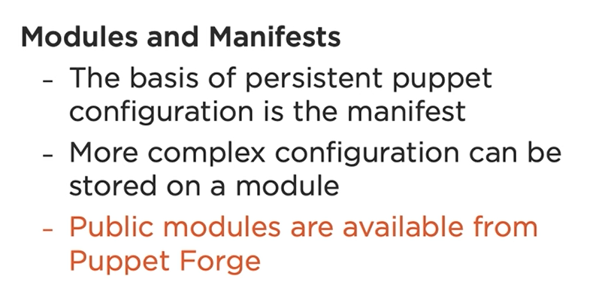

<https://forge.puppet.com/>

demo

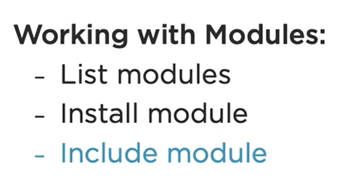

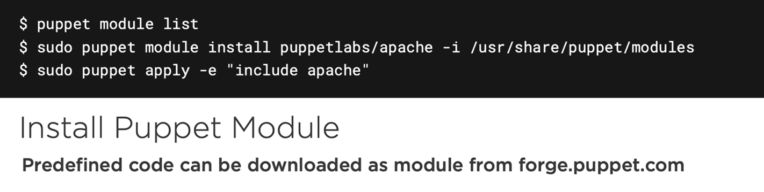

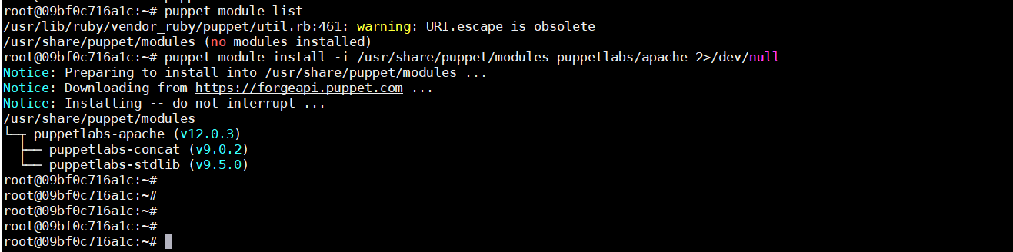

## Chapter 6.5: Understanding Manifests

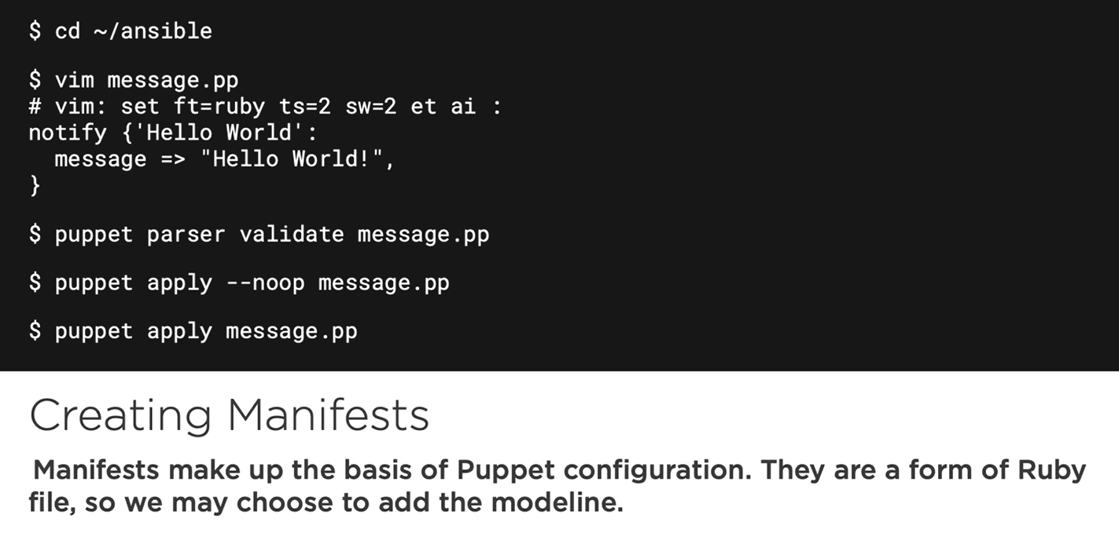

Puppet parser validate message.pp // checking syntax and validate

Puppet apply –noop message.pp //smoke test, apply without operation

Puppet apply message.pp //have not -e option, go straight to apply

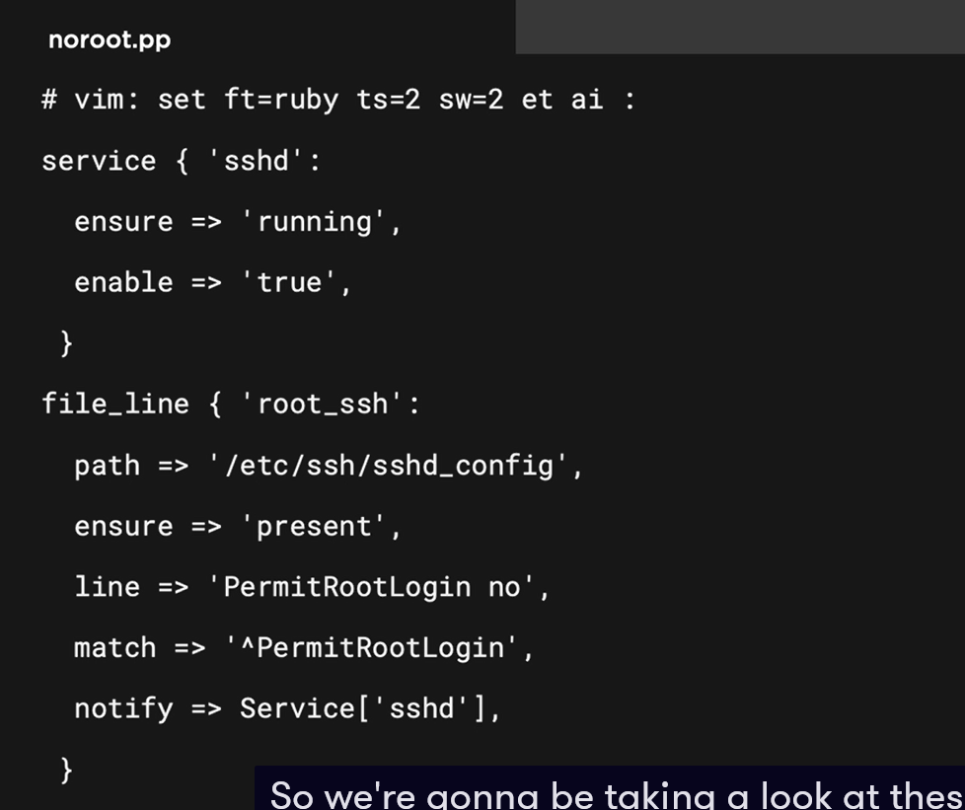

## Chapter 6.6: Working with Manifests

Should review if need

## Chapter 6.8: summary

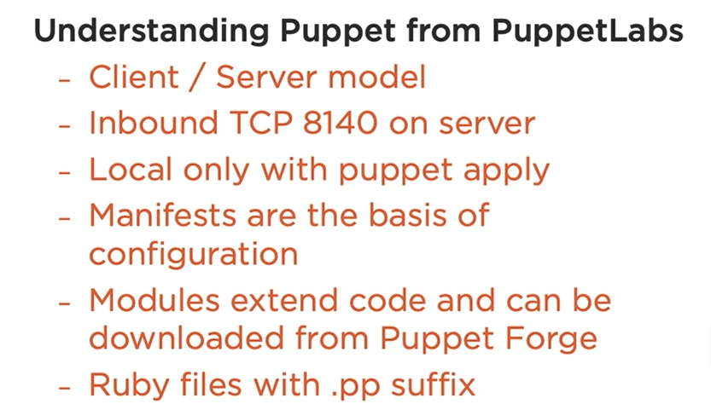

# Chapter 7: Implementing SaltStack for Configuration Management

## Chapter 7.1: Introduction to SaltStack

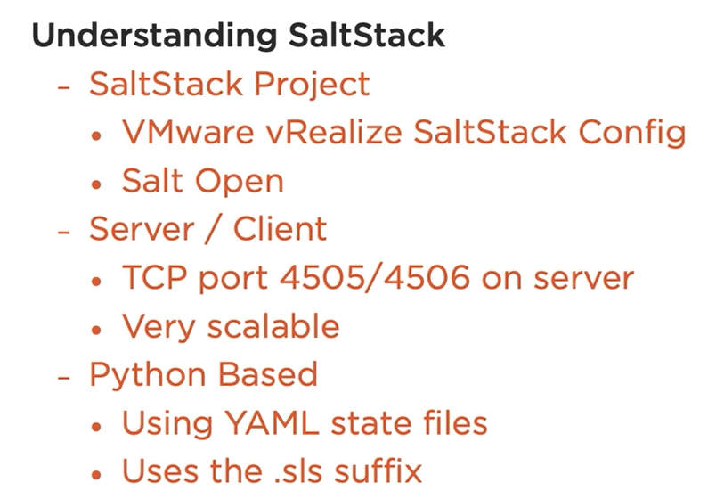

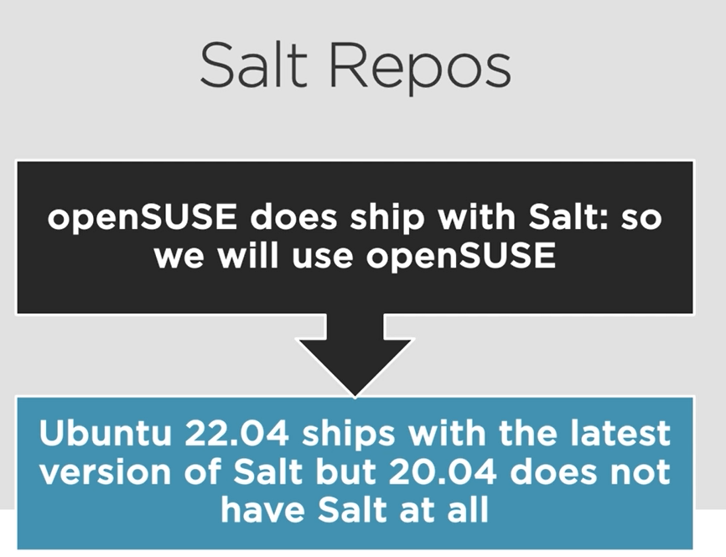

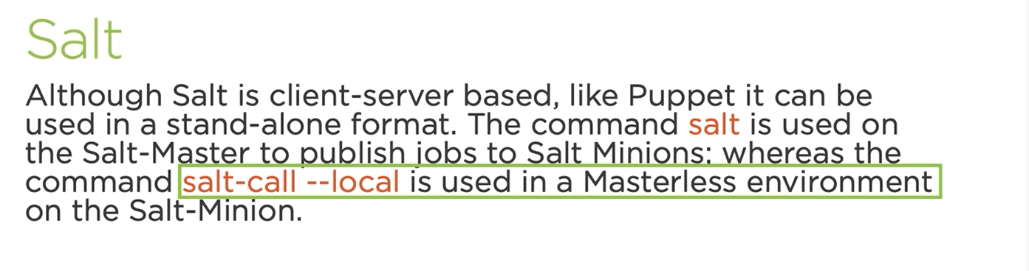

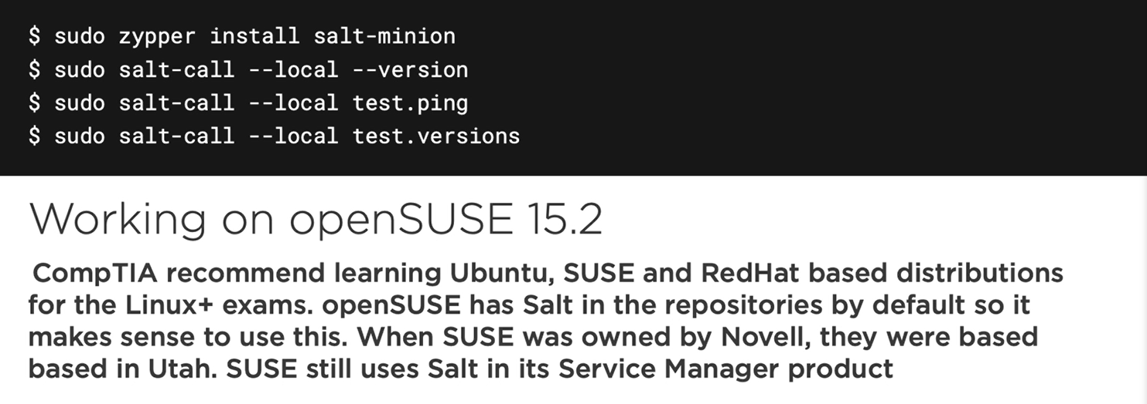

## Chapter 7.2: Installing Salt on openSUSE 15.2

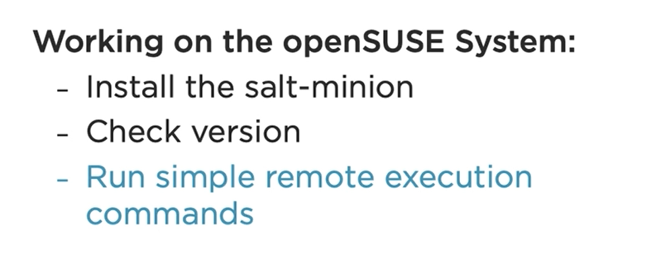

Zipper in git -y

Zipper in salt-minion -y

Git clone <https://github.com/theurbanpenguin/comptia-automation.git>

Sudo Salt-call –local –version

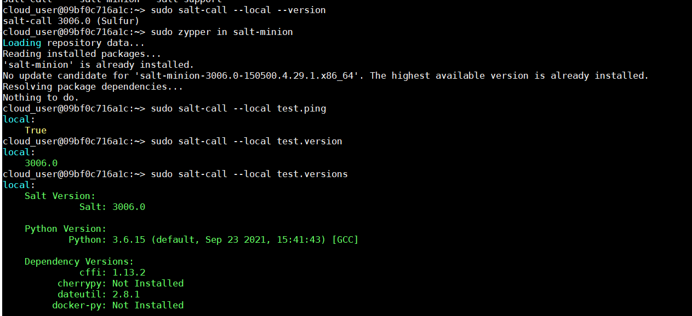

## Chapter 7.3: Reading CLI Documentation

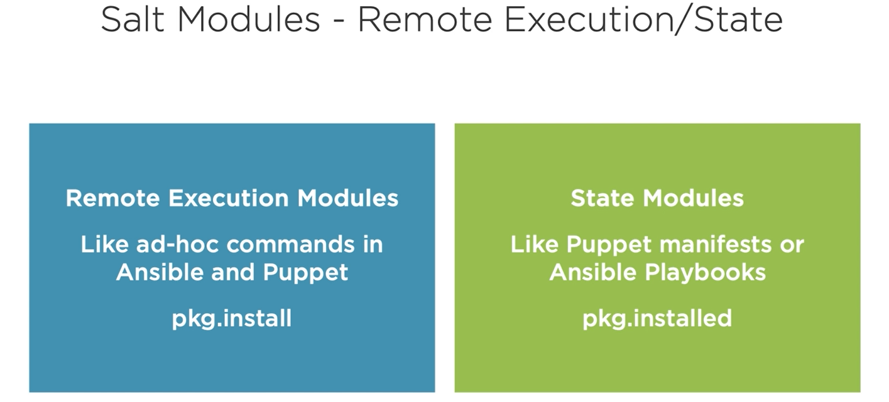

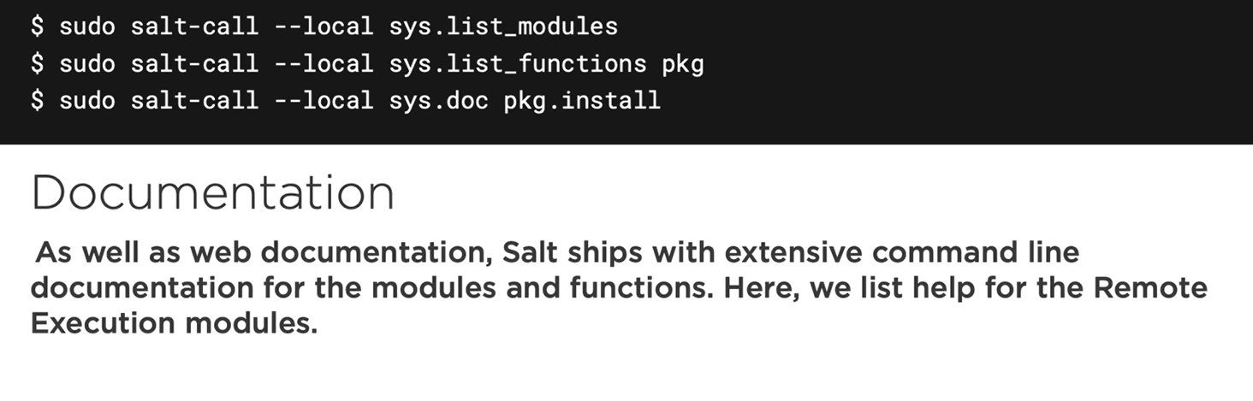

Demo

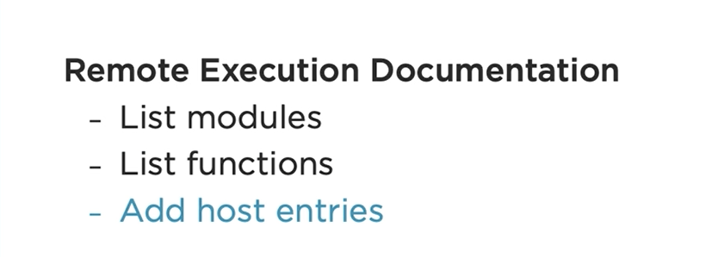

List modules on salt

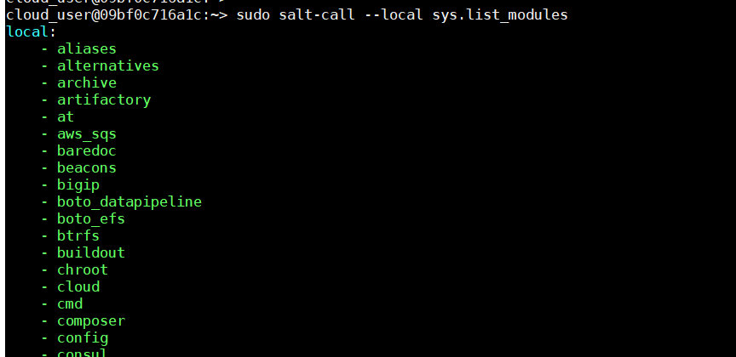

List functions on module pkg

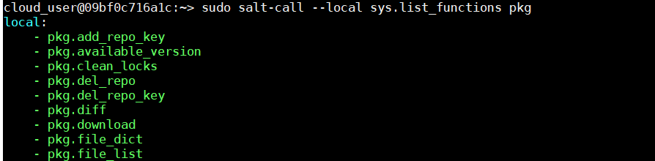

Checking documentation of function

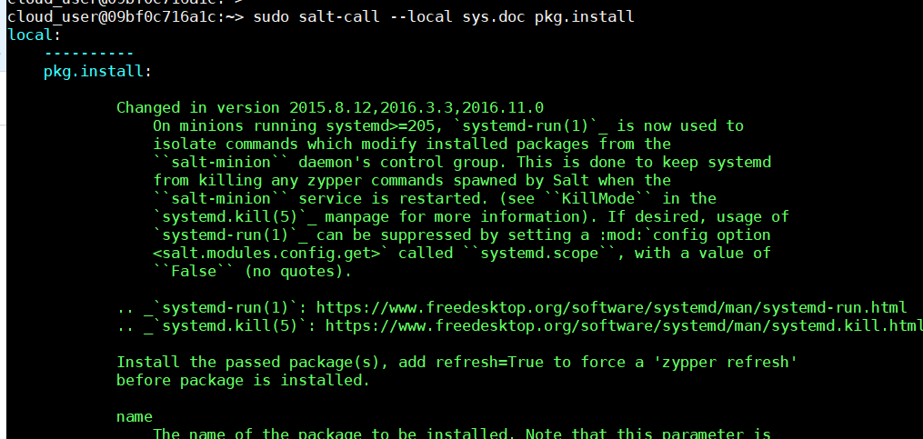

Deep dive into particular funtions of a package



Review again this command



Adding Host_add function example

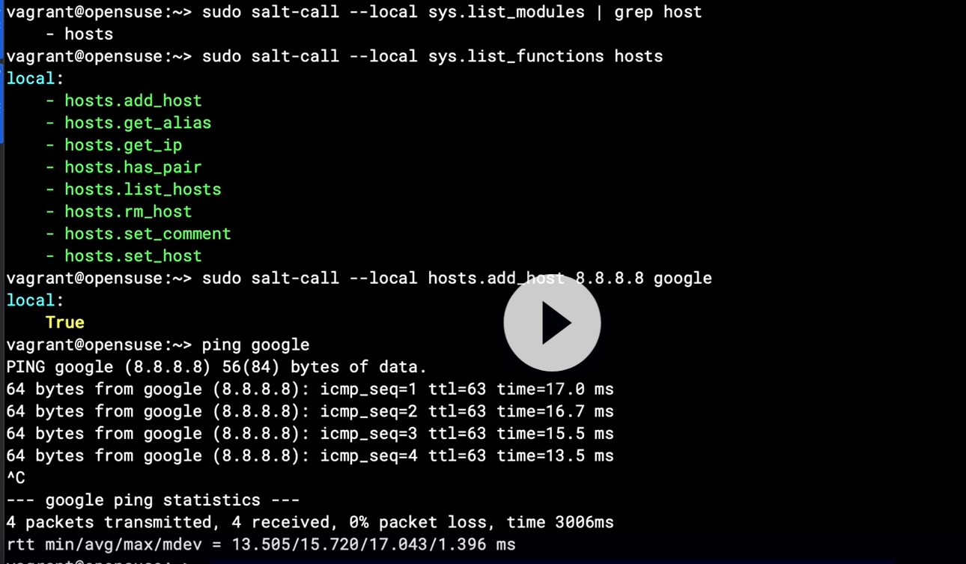

## Chapter 7.4: Understanding Salt State Files

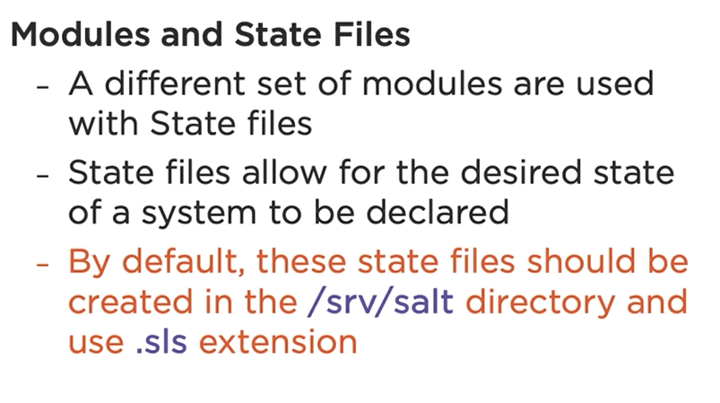

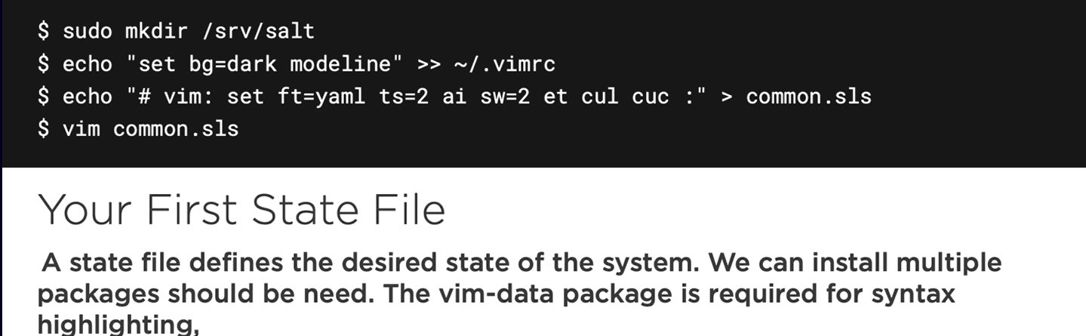

Config .sls configuration file for some convenient

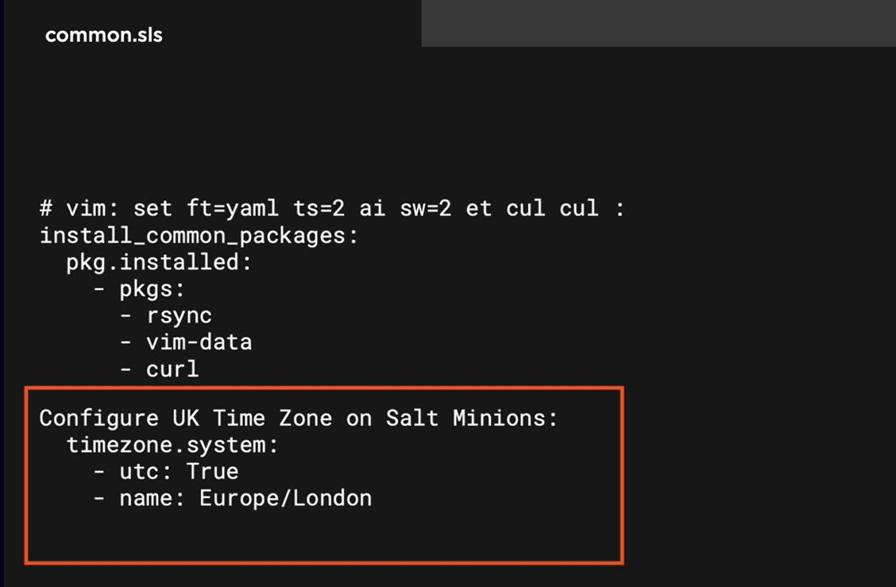

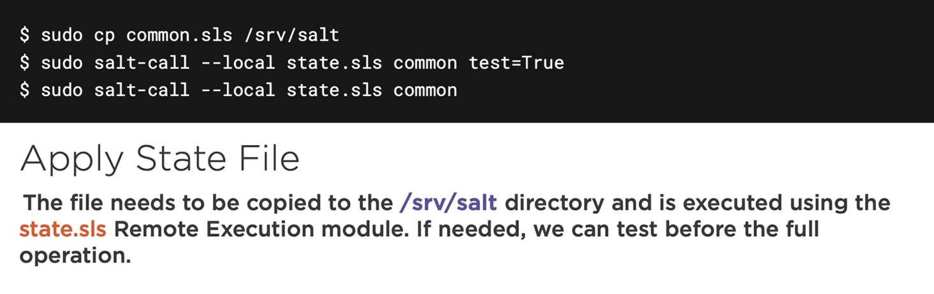

## Chapter 7.5: Working with Salt States

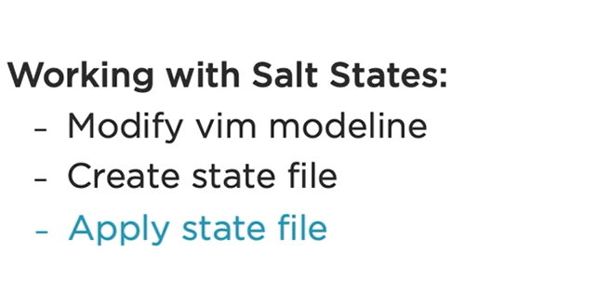

## Chapter 7.6: summary

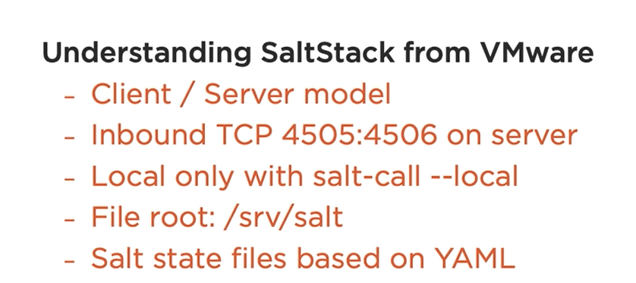

# Chapter 8: Implementing Chef for Configuration Management

## Chapter 8.1: Welcome to Chef

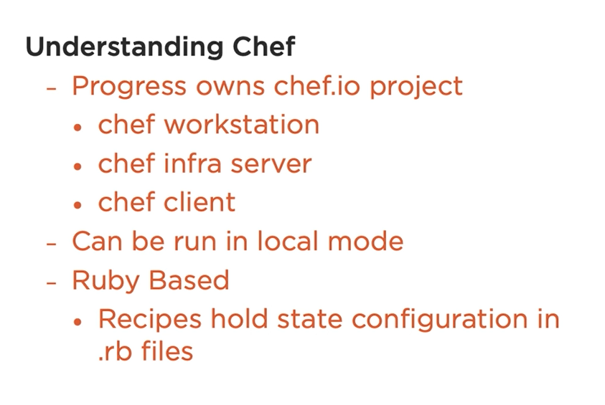

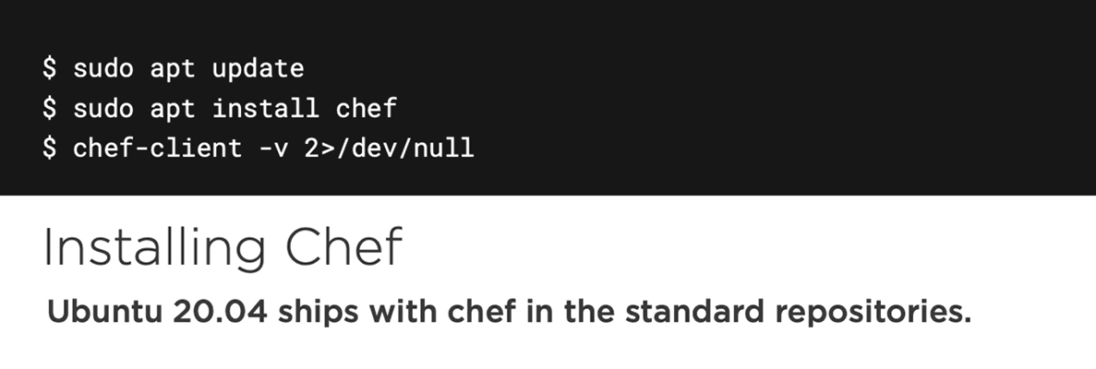

## Chapter 8.2: Working with the Git Resource

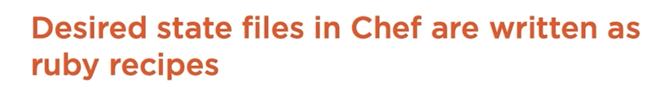

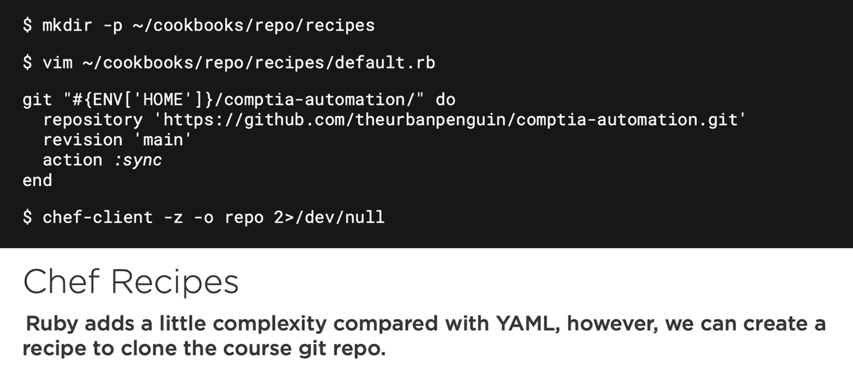

Note: escape and dot for calling latest argument

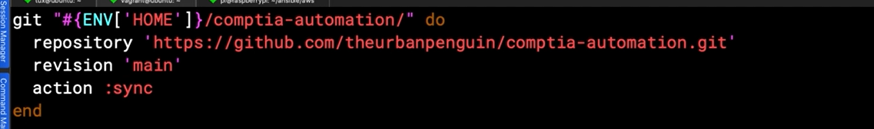

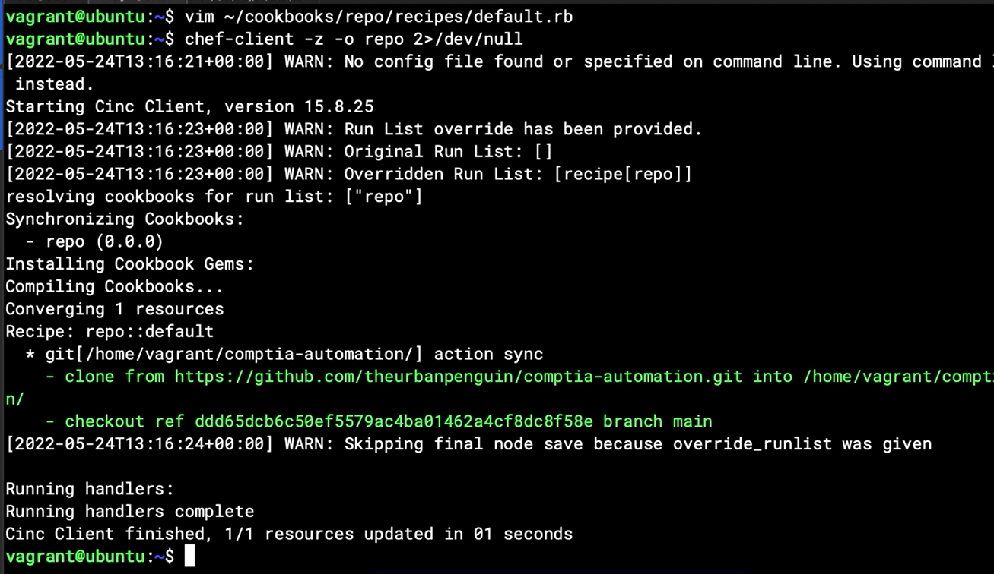

## Chapter 8.3: Working with Files

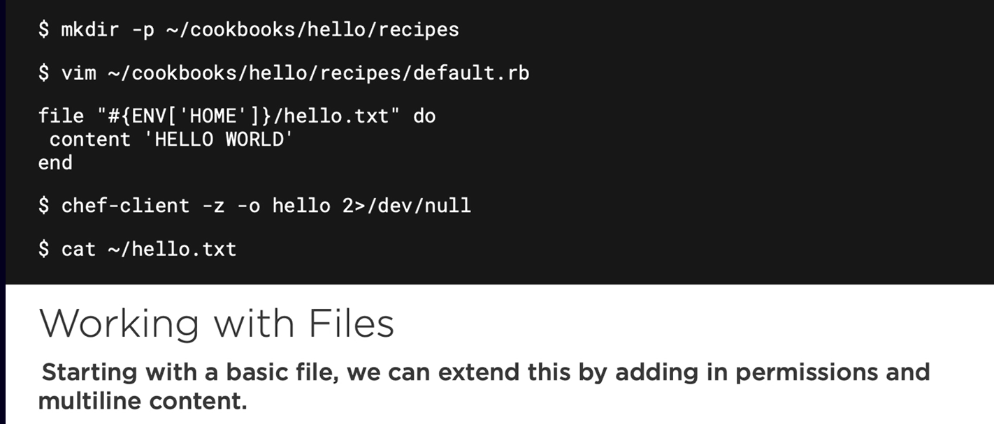

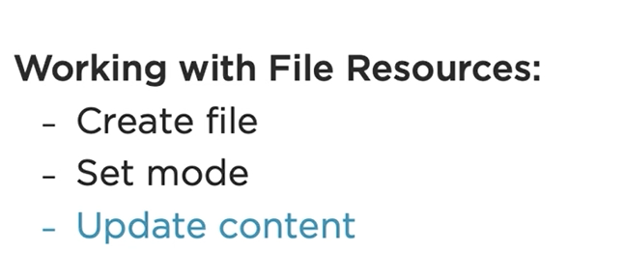

Create new file on another directory

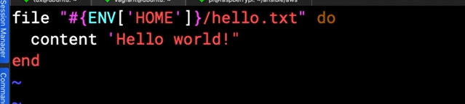

Another version

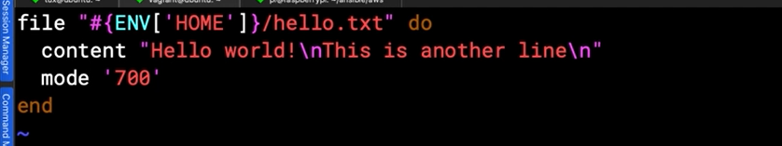

## Chapter 8.4: Working with Packages and Lists

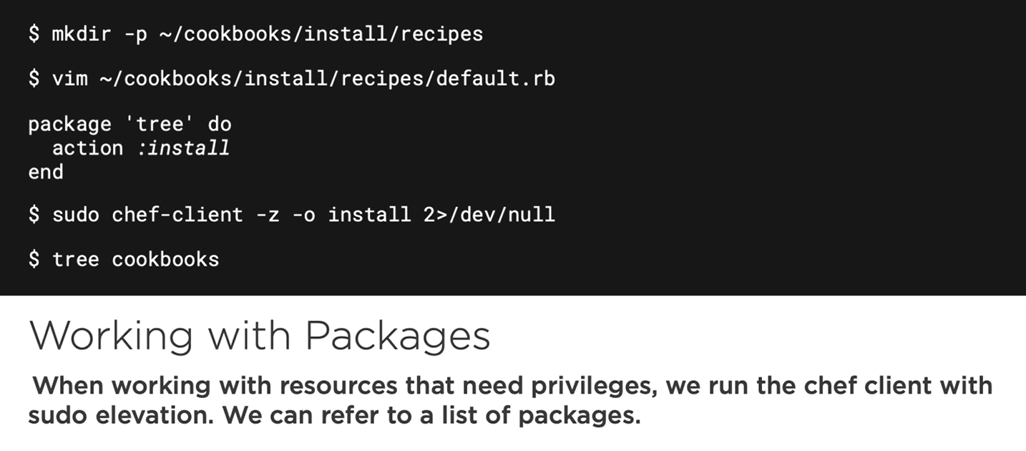

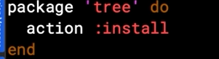

Another way declaration of list quicker than using square brackets:

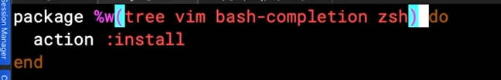

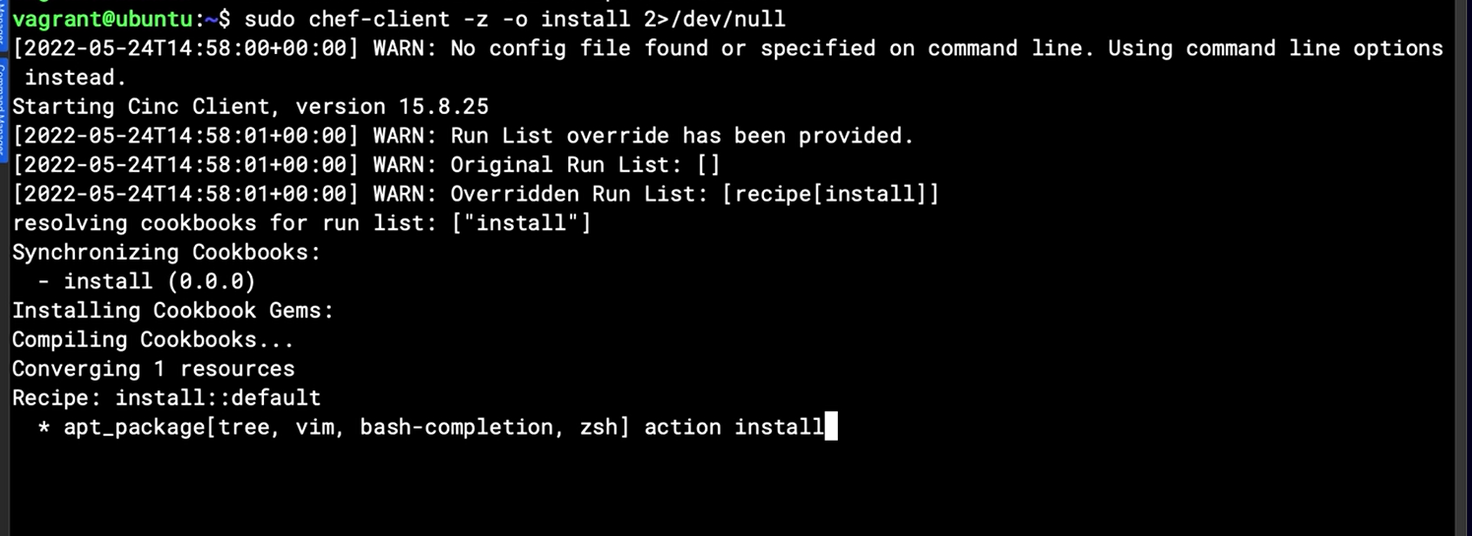

## Chapter 8.5: summary

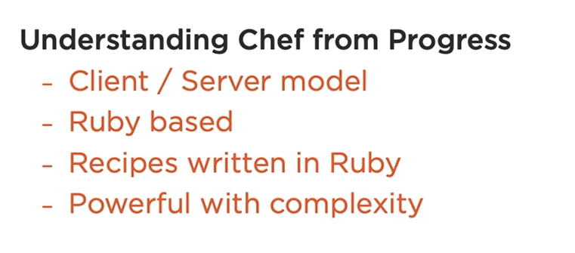

# Chapter 9: Implementing Terraform to Deploy Your Virtual Machines

## Chapter 9.1: Introduction to Terraform

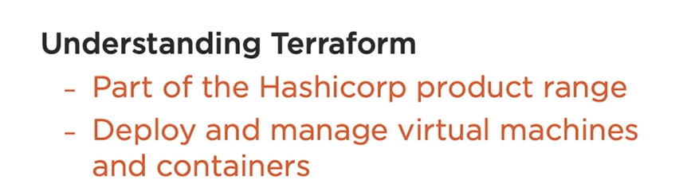

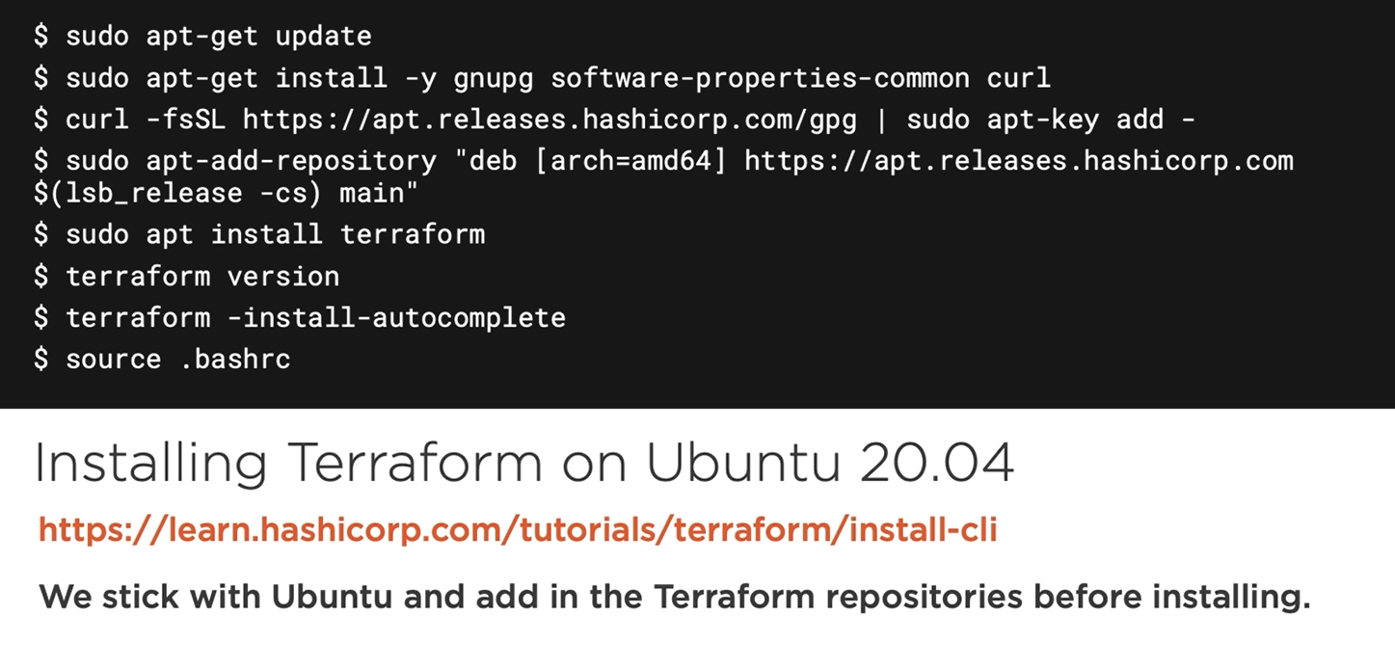

## Chapter 9.2: Installing Terraform

Bash ./$HOME/comptia/terraform/terraform.sh

## Chapter 9.3: Working with Terraform Providers

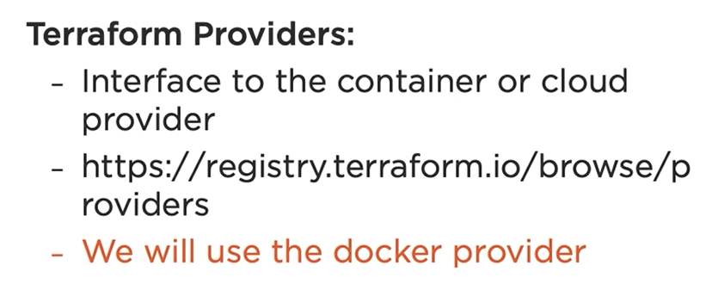

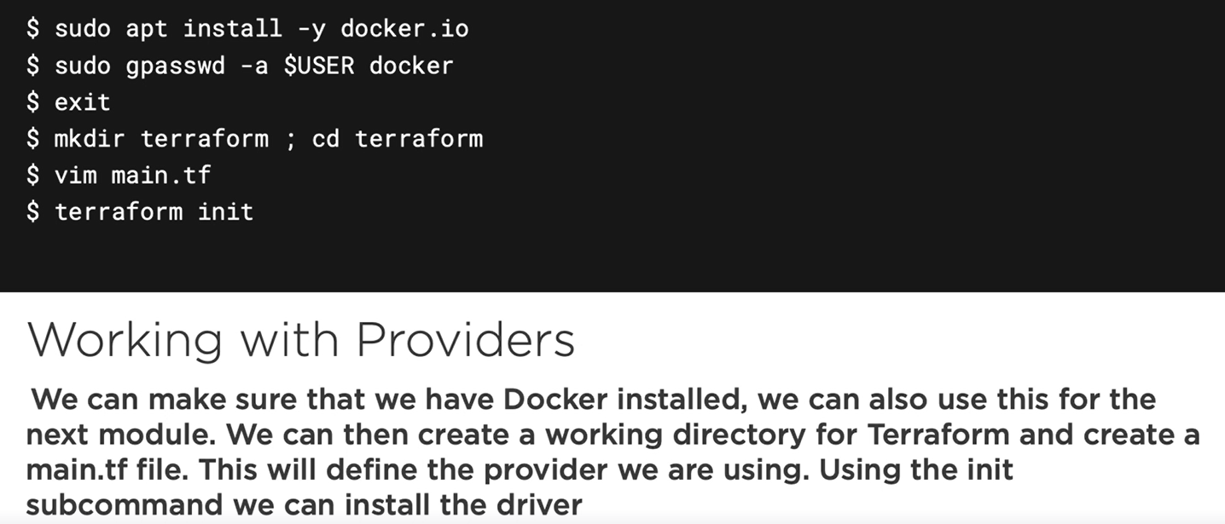

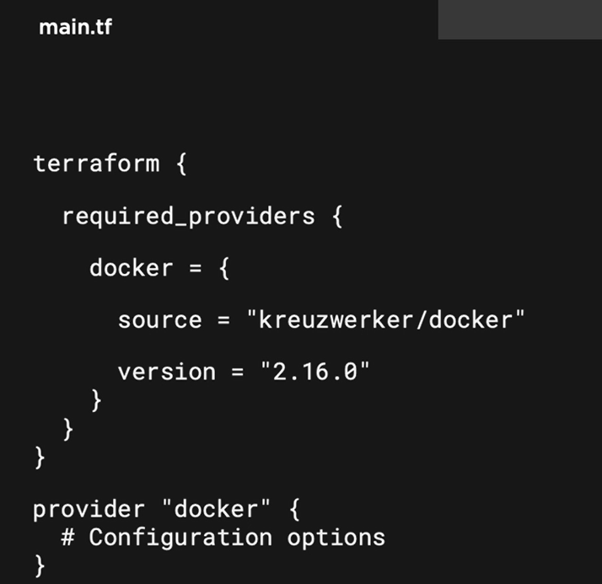

Demo

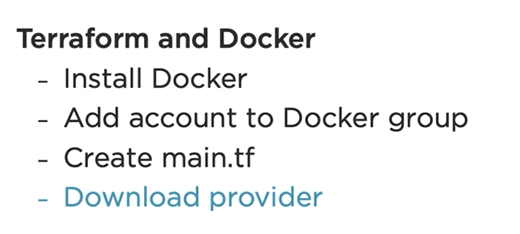



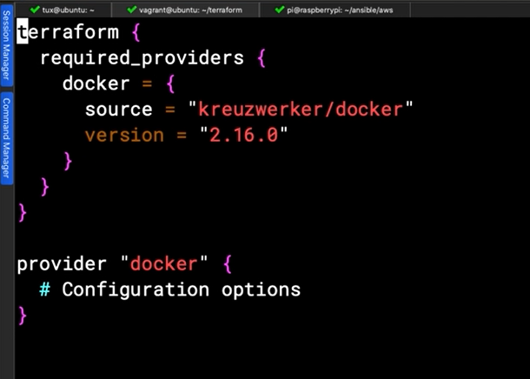

## Chapter 9.4: Working with Docker

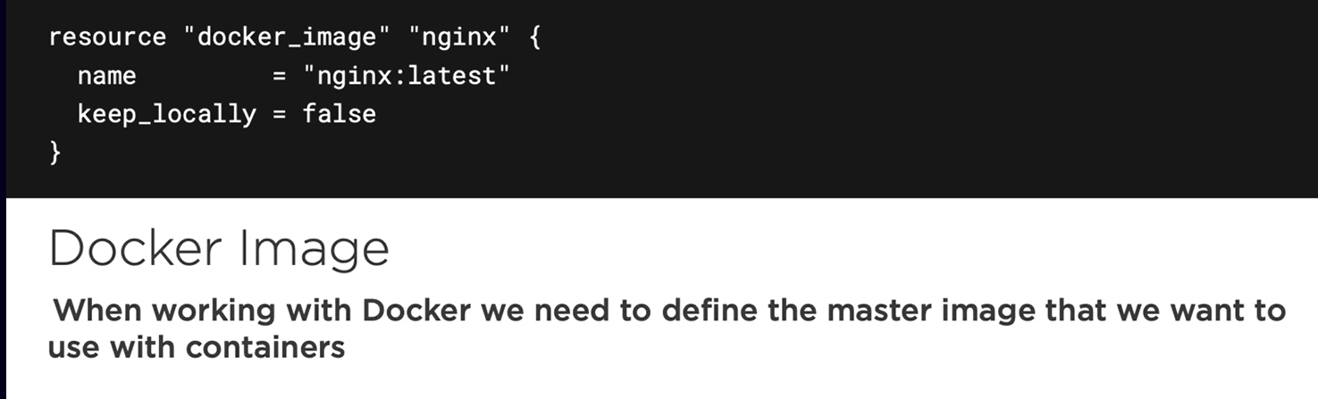

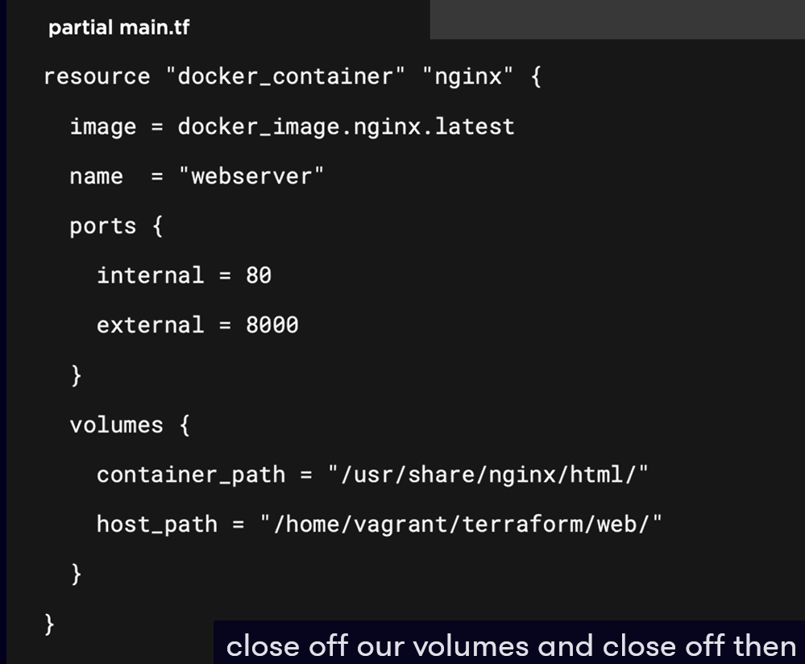

## Chapter 9.5: Creating Docker Resources

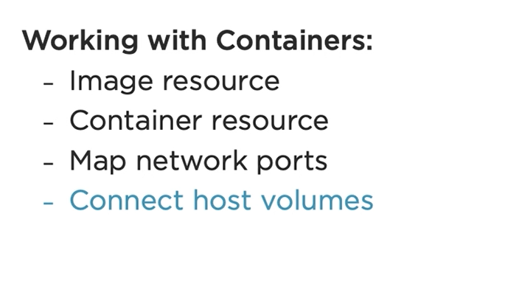

Tip:

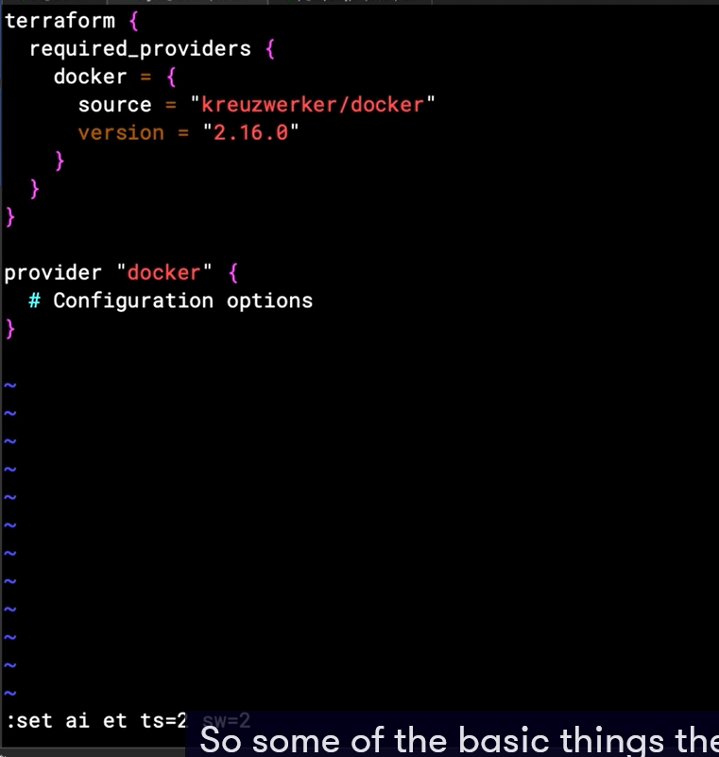

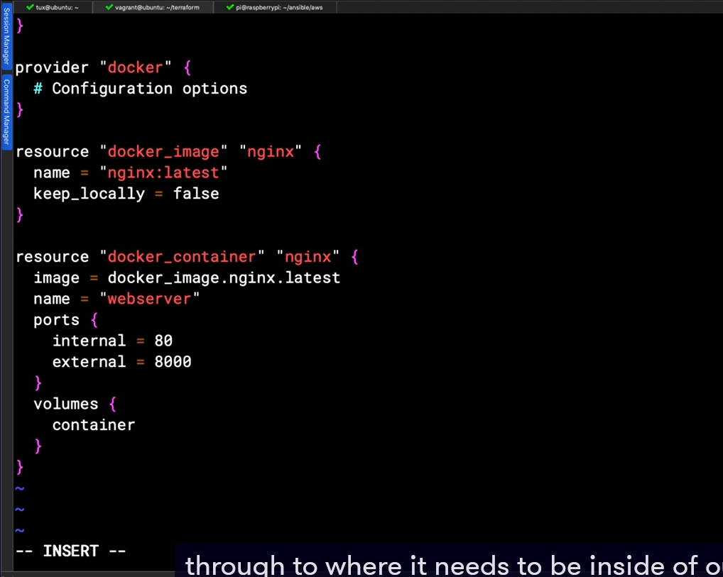

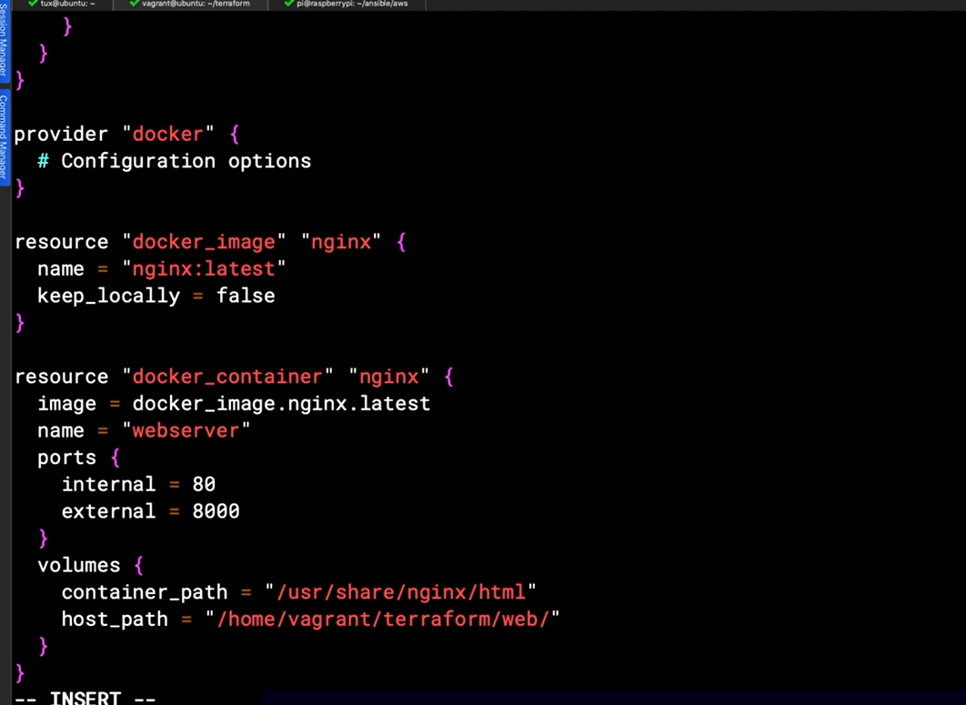

Note: to destroy “terraform destroy” to deploy “terraform apply”

## Chapter 9.6: Capstone Demonstration Using Ansible to Deploy Terraform and Project

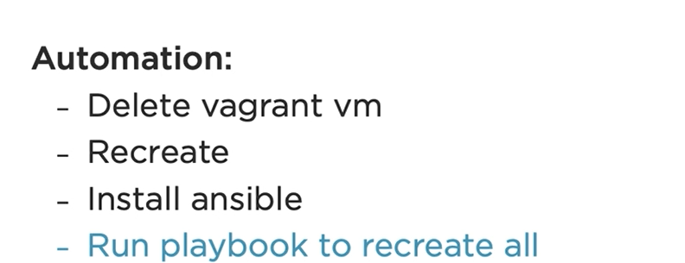

Note: you can create a playbook with suffix anything you want, doesn’t matter what is if you have color code in your playbook file.

## Chapter 9.7: Summary of What's Next

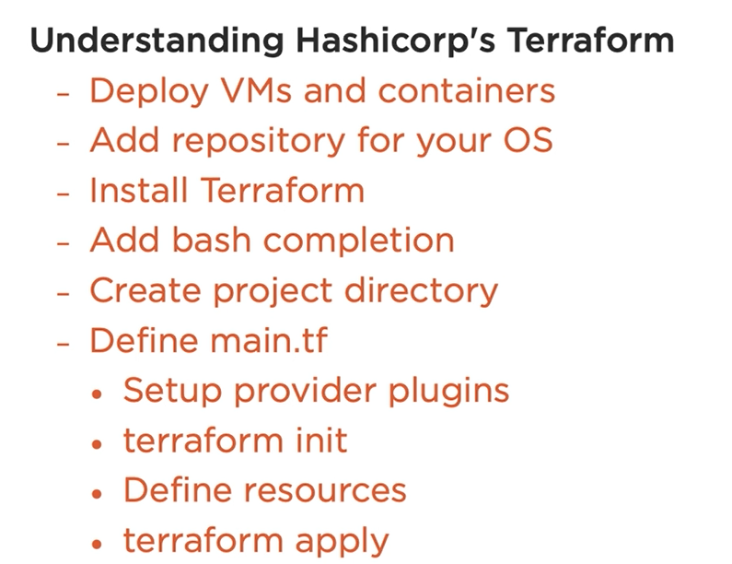

# Chapter 10: Implementing Containers Using Docker

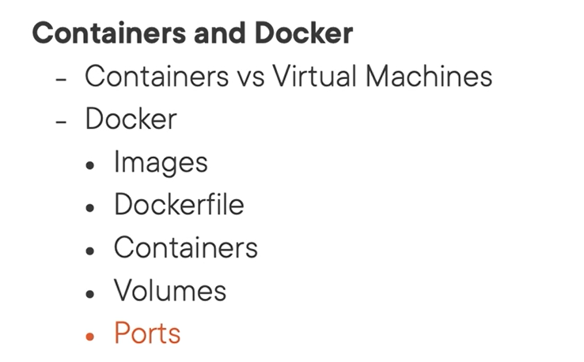

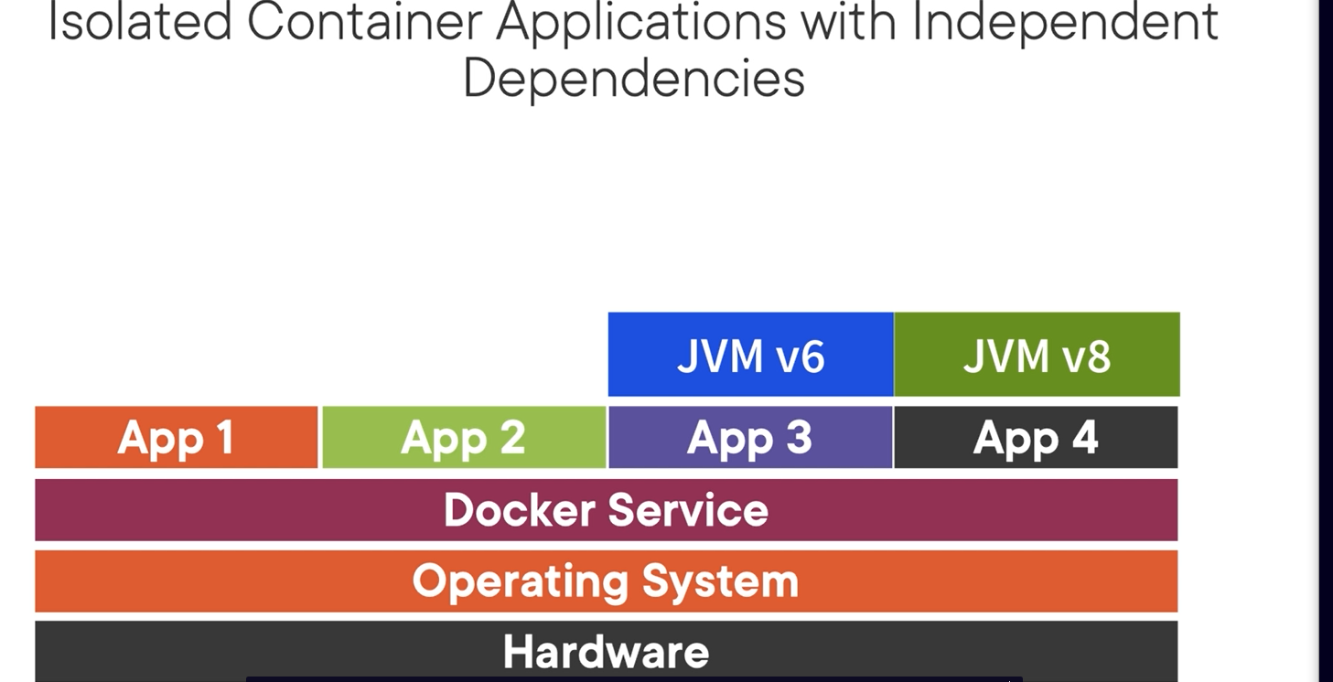

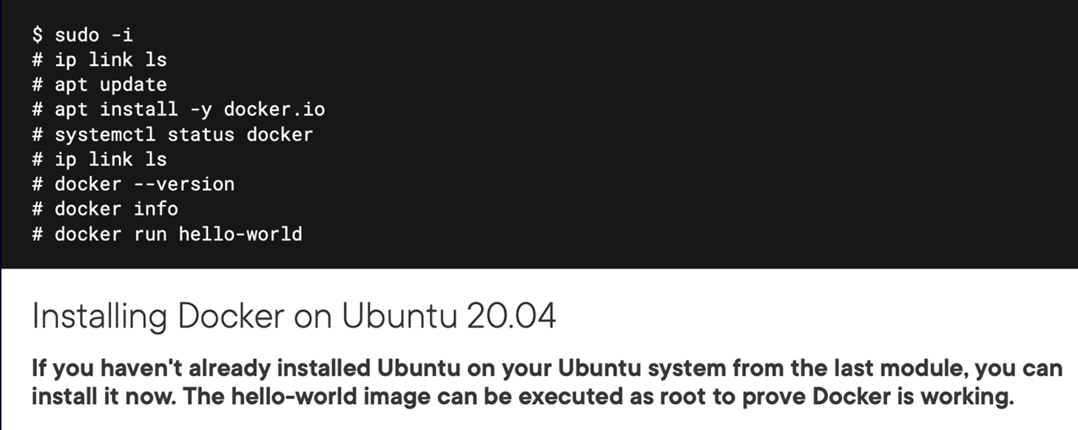

## Chapter 10.3: Understanding the Security Weakness of the Docker Group

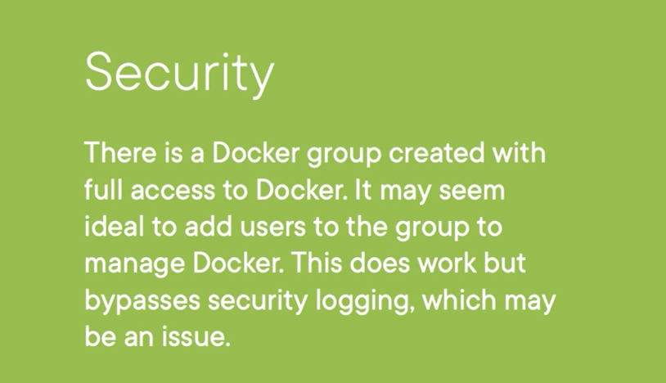

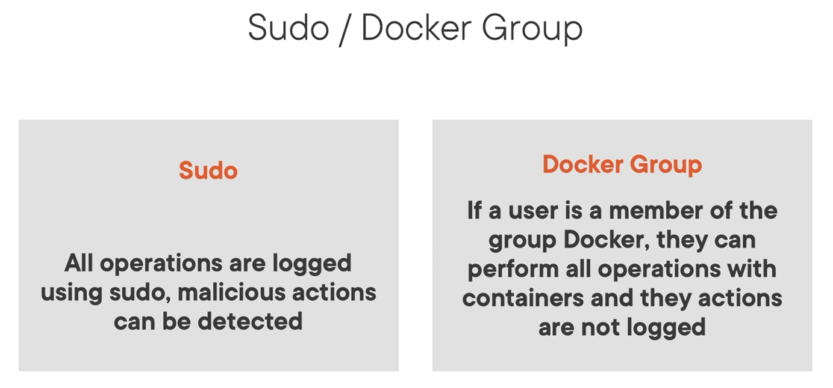

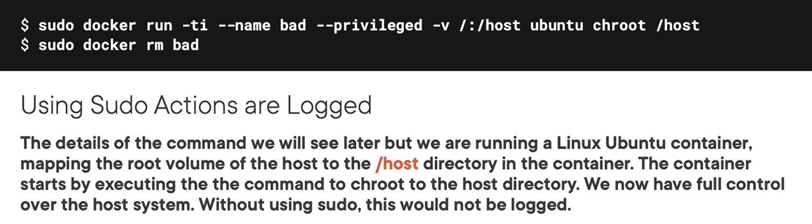

## Chapter 10.4: Working at the CLI to Show Unlogged Operations When Not Using Sudo

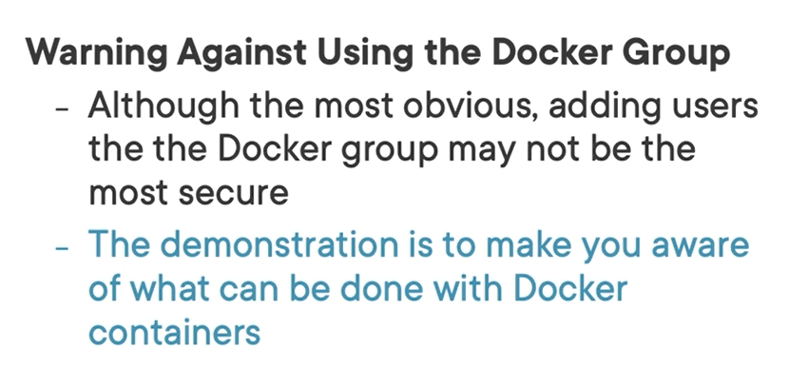

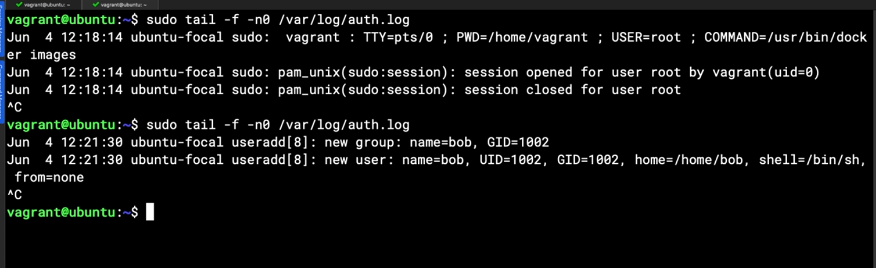

Above you wont see who are running the command if you add $USER to group of docker (this case docker group have priviledge )

## Chapter 10.5: Working with Docker Images

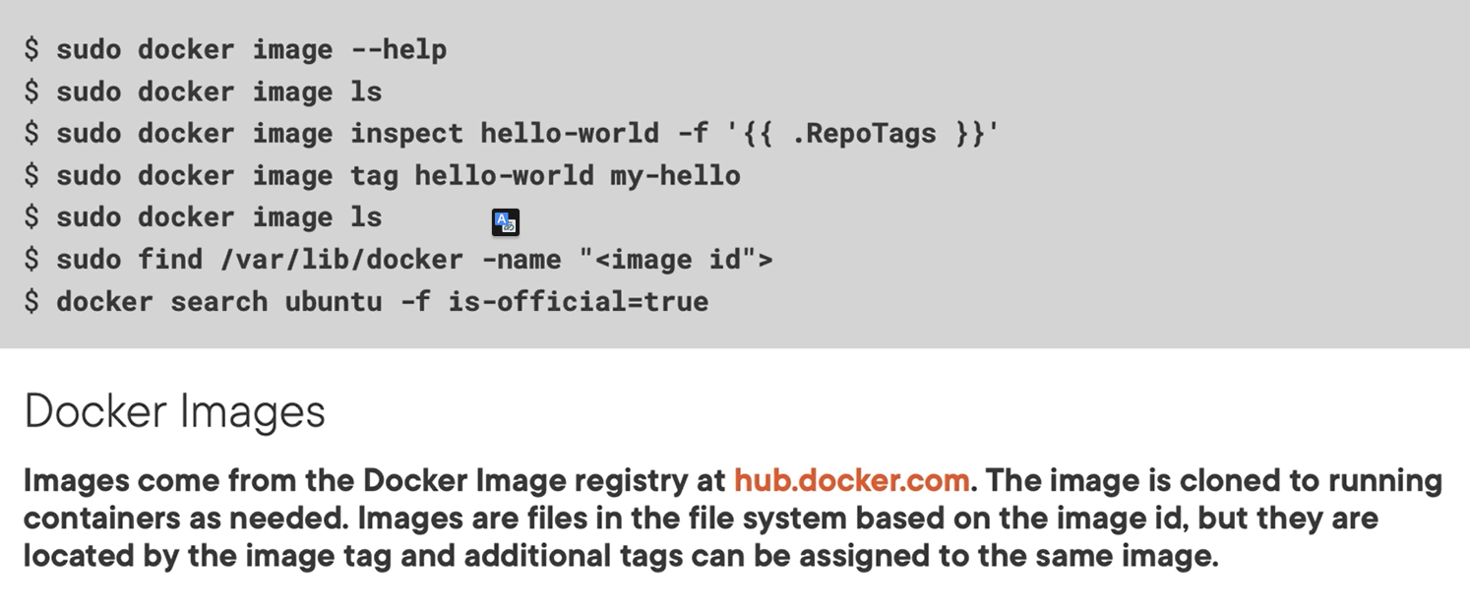

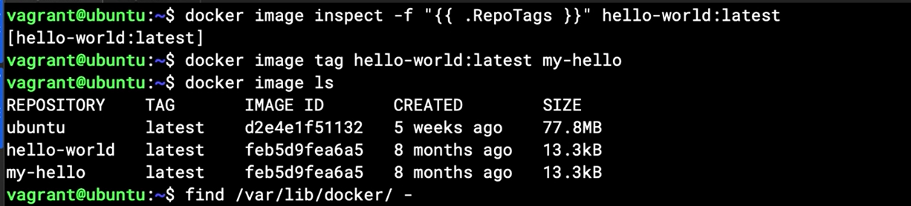

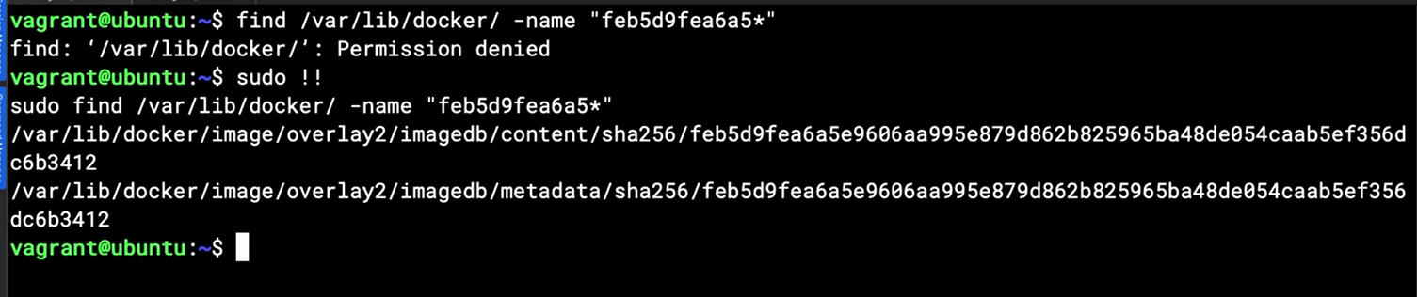

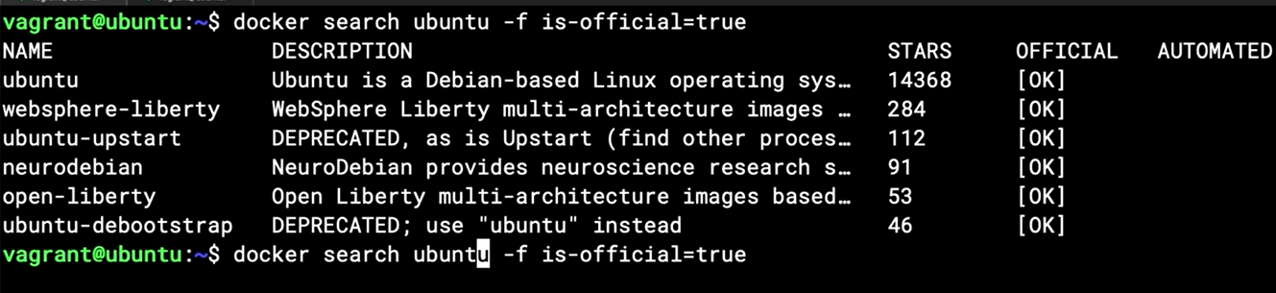

## Chapter 10.6: Working with Docker Containers

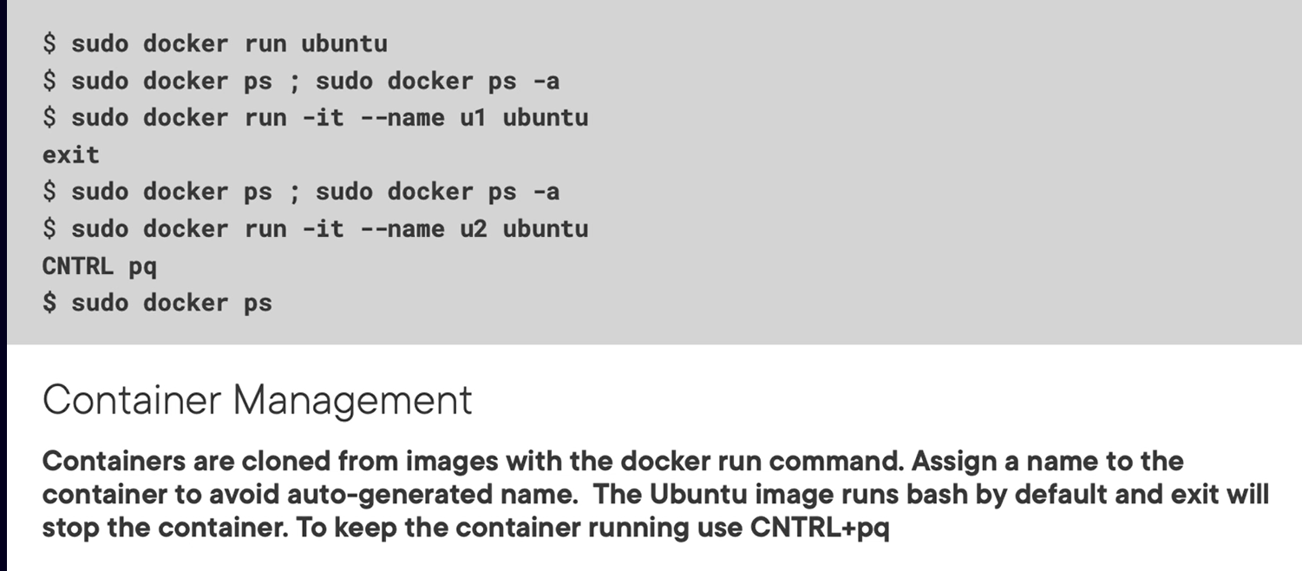

## Chapter 10.7: Working with Services in Containers

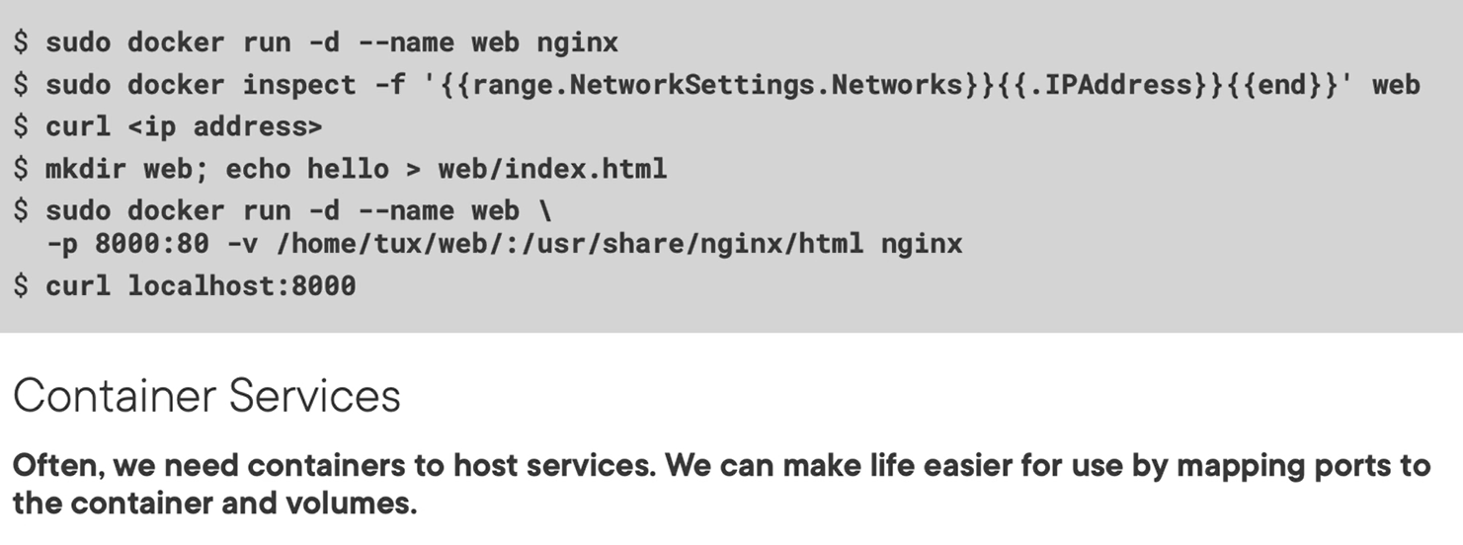

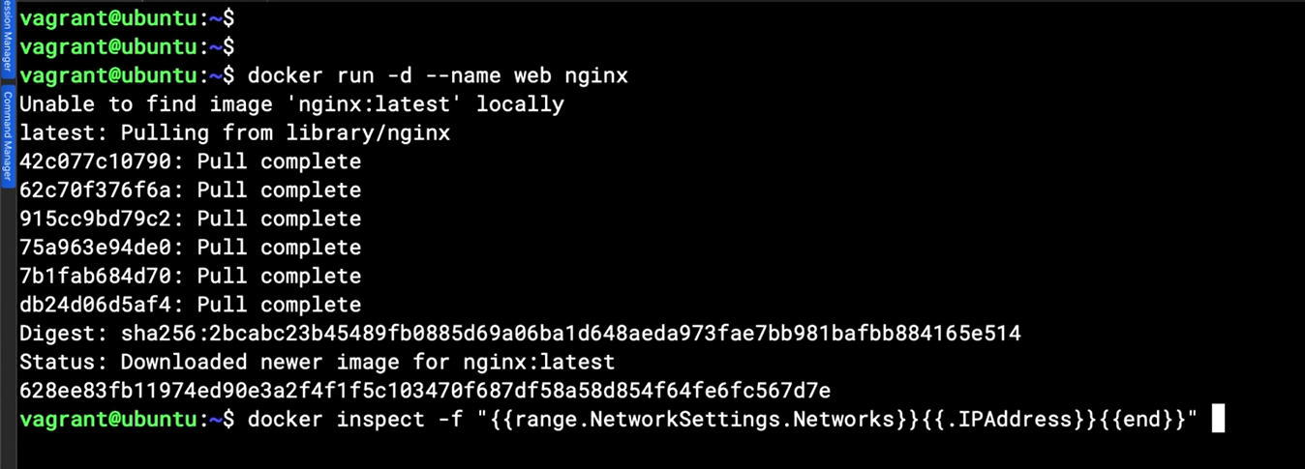

Note: ctrl + E to move to back end of the line

## Chapter 10.8: Building Images with Dockerfile

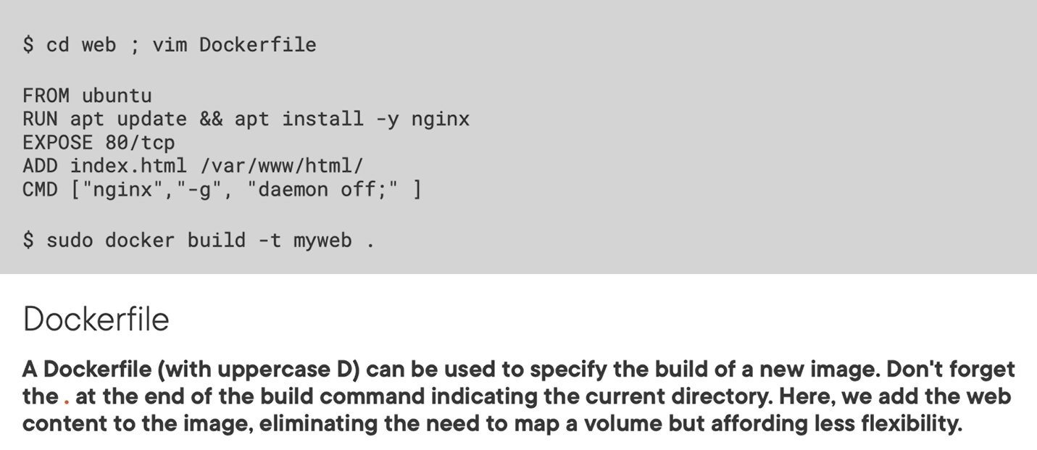

## Chapter 10.9: Summary and What's Next

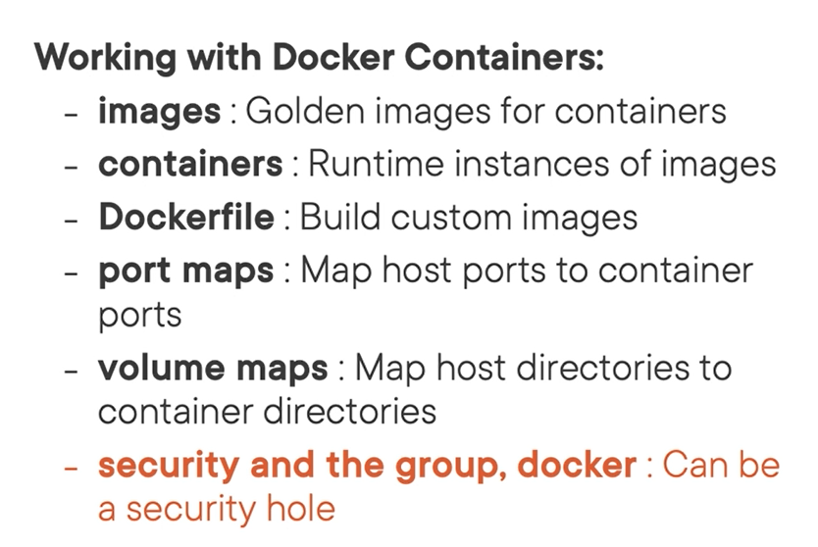

# Chapter 11: Managing Container Micro Services Using Kubernetes

## Chapter 11.1: Installing MicroK8s

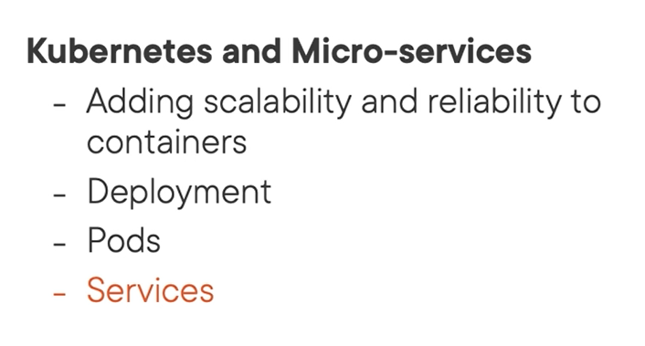

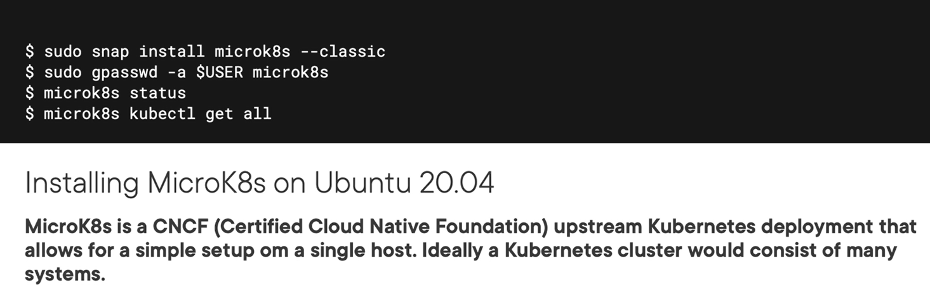



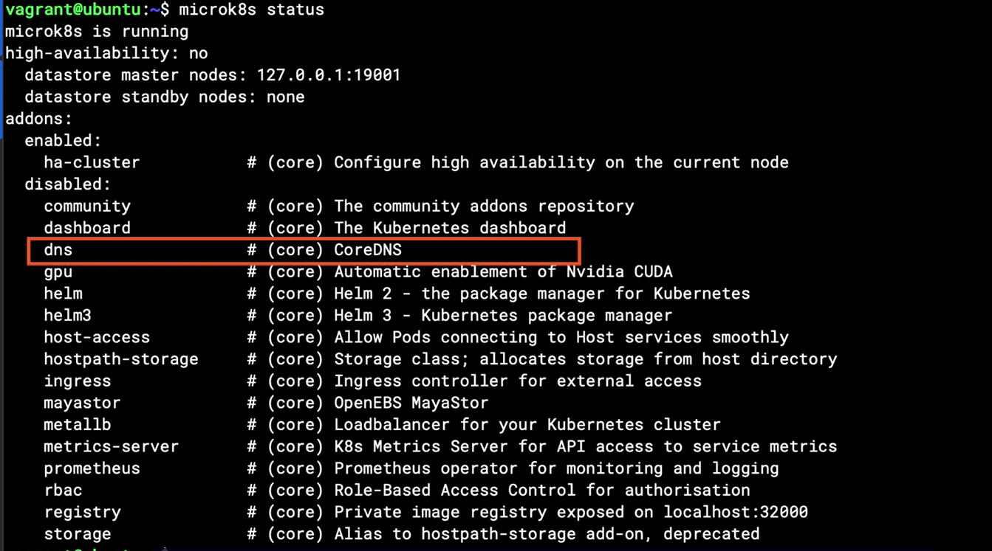

Checking services

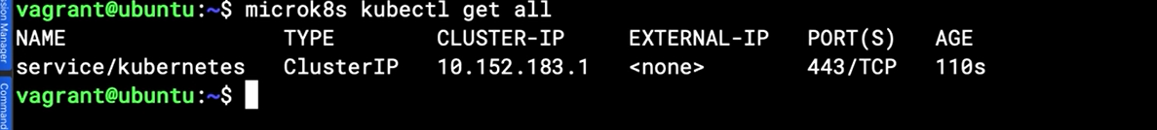

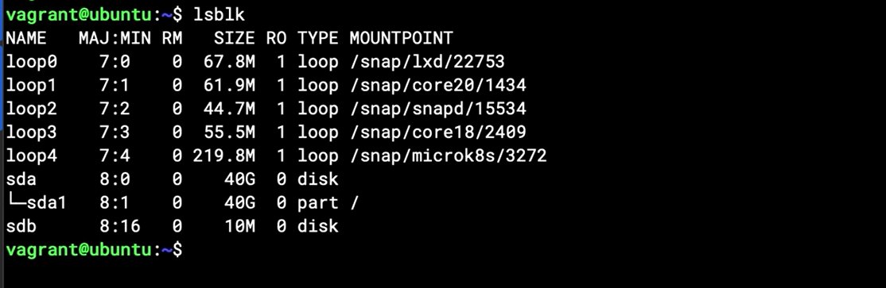

## Chapter 11.2: Creating Micro services in Kubernetes

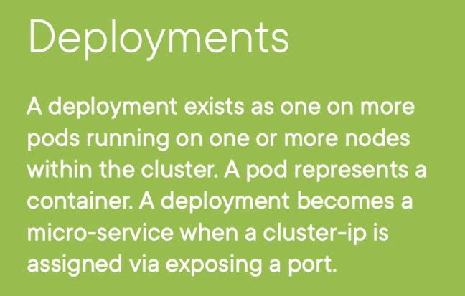

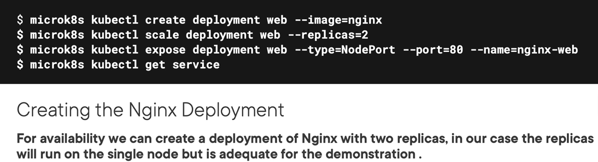

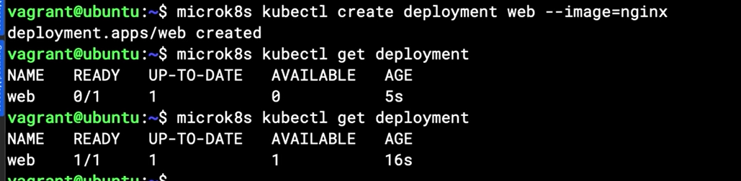

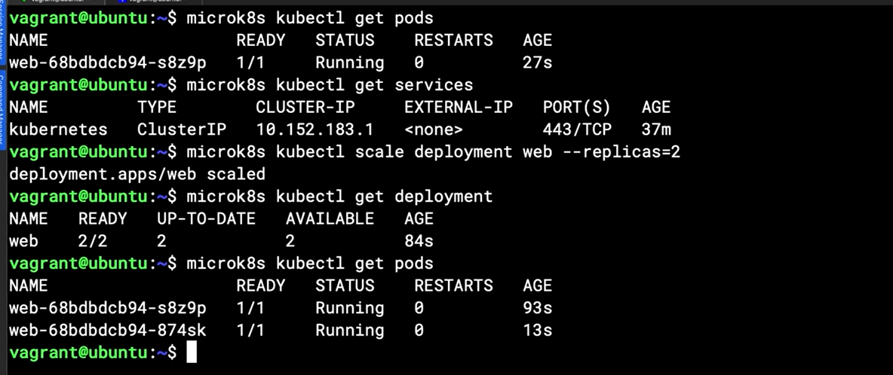

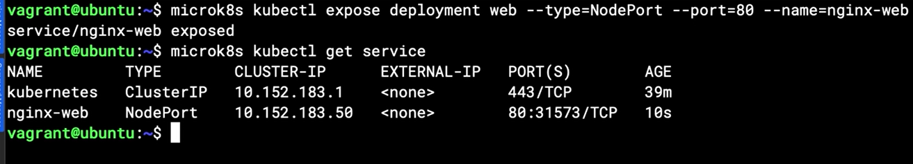

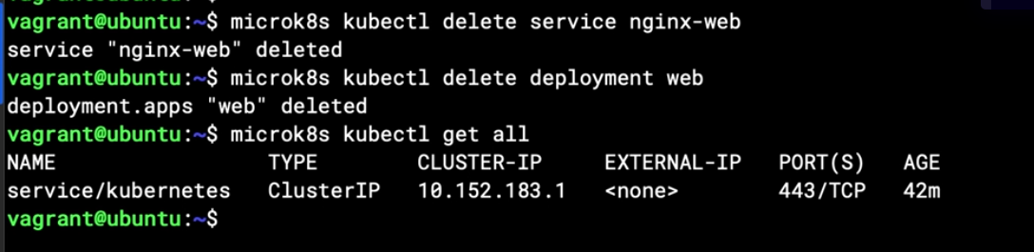

## Chapter 11.3: Summary

# Resource

<https://learn.acloud.guru/course/b9225ba8-8593-449a-a09b-88ae98f9feaa/learn/739cd789-d4cc-4ffa-841b-5fc62f816003/8157867c-343f-4a9a-b939-f5906efa4ff6/watch>